**Design Proposal EE-421X/EE-471W**

14 December 2021

Team Members:

Alex Rice, Charles McElroy, Chris Krush, Fawaz Rudd, Garrett Johnson, Gordon Mathiesen, Ishmael Taylor, Jeremiah Gaulding, Jerrod Hunziker, John Angerer, Karin Teekha, Michael Jackson, Nia Vaughan, Nicholas Bryson, Samuel Estes, and Trevor Weygandt

Faculty Advisors:

COL Addington, COL Barr, and LTC Feinauer

Help Received:

IEEE Template, Citation Machine for MLA format

Contents

Executive Summary 5

A. Needs Statement 5

B. System Specification 5

Requirements Analysis Section 8

C. Requirements Analysis 8

D. Marketing Requirements 8

E. Engineering Requirements 8

1) Performance 8

2) Functionality 8

3) Economic 8

4) Energy 8

5) Environmental 9

6) Health and Safety 9

7) Legal 9

8) Maintainability 9

9) Manufacturability 9

10) Operational 9

11) Political 9

12) Reliability and Availability 9

13) Social and Cultural 9

14) Usability 9

F. Requirement validation 11

Functional Analysis/Allocation 12

G. The Level 0 Systems View 12

1) Level 0 Diagram 12

2) Process Model Flow Chart 13

H. The Level 1 Subsystems View 13

I. Level 2 Subsystem Breakdown or Component level views 16

1) Vision Function 17

2) Grab Function 17

3) Throw Function 18

4) Block Diagrams - Component Level 19

Analysis of Alternatives 22

J. Overall Strategy 22

K. Robot Systems Evaluation Cirteria 23

1) Computer Vision Evalation Cirteria 23

2) Controller Evaluation Criteria 23

3) Drivetrain Evaluation Criteria 23

L. Establishing Criteria Intent 23

1) Computer Vision Criteria Intent 23

2) Controller Criteria Intent 24

3) Drivtrain Criteria Intent 24

M. Defining Alternatives 24

1) Computer Vision Alternatives Definition 24

2) Controller Alternatives Definition 25

3) Drivetrain Alternatives Definition 25

N. Decision Review 26

1) Computer Vision Decision Review 26

2) Controller Decision Review 26

3) Drivetrain Decision Review 26

O. Further Discussion of Design Alrternatives 27

Synthesis 31

A. Functional/Physical Matrix 31

A. System schematic block diagram 32

B. System Design Analysis 33

1) Software System Design Analysis 33

2) CAD Progression 38

3) System Viability 41

C. System Summary 43

D. Progress 44

Testing 47

E. Drivetrain Subsystem Testing 47

1) Plan 47

2) Results 47

B. Recover Beads Subsystem Testing 49

1) Plan 49

2) Results 50

C. Launcher Subsystem Testing 51

1) Plan 51

2) Results 51

D. Integrated Systems Testing 53

1) Plan 53

2) Results 53

E. Testing Conclusions 54

Project plan 55

F. Team Member’s Skills 55

1) Electronics Team: 55

2) Hardware Team: 55

3) Software Team: 56

4) Leadership: 56

B. Project Assignments 57

1) Electronics 57

2) Software 57

3) Hardware 57

4) Leadership 57

C. Work Breakdown Structure 58

D. Gantt Chart 60

E. Work Package 64

F. Budget Allocation 64

Sources 67

Appendicies 68

A. ABET Requirements 68

B. C&C Responses 69

C. Acronyms 70

# Executive Summary

## Needs Statement

“In 2022, besides the regular Mardi Gras parades, Mobile will host a national robotic parade competition, in which robotic floats will navigate through a smaller scale rout performing similar tasks as our original Mardi Gras parade on streets. In this competition, your robot will be a float throwing beads and moon pies and cleaning up obstacles from the streets while avoiding hurting the audience and the beautiful buildings of our Mobile port city. Your float will also show your pride in your school, playing a fight song or displaying your mascot.”[1]

## System Specification

The purpose of the robot is to score the highest number of points possible while autonomously navigating the Mardi-Gras themed game board. The game board the robot navigates consists of a 16-inch-wide L-Shaped Road with a white line down the center. The robot must begin in the 1ft by 1ft starting square, move forward and conduct a 90-degree turn to the right and traverse the remaining 6 feet of the road.[2] On either side of the road will be 2” tall barricades which the robot is restricted to touch without the loss of points. There will be obstacles placed throughout the game board to restrict the robot’s motion. These obstacles include a power line running perpendicular to the road that the robot must pass under, and a marshmallow randomly placed onto the road. The robot receives 5 points for traversing the game board once and receives 10 points for conducting a full loop and completing the track in both directions. The complete visual for the game board can be viewed below in Figure One[3]:

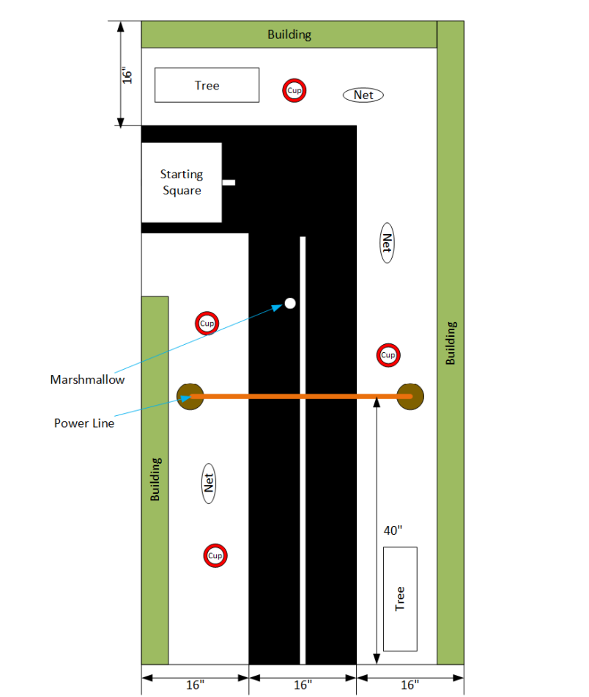

Figure , Game Board Layout and Specifications

One of the principal specifications for the robot is that the size of the robot must be 1ft by 1ft by 1ft, although specific components of the robot can extend beyond these dimensions after the start of the competition.[4] These dimensions will be tested by the judges by placing a box with these dimensions over top the robot before the start of the competition. Another important specification for the robot is that the robot must run autonomously after the robot is started by the team lead. The Robot will be started by a clearly labeled start button. Furthermore, the specifications for the robot encourage hardware features to represent the robot as a float in a Mardi-Gras parade. These potential features include a school themed exterior, a light up display with the capability to move mechanically four inches, and the ability to play a song.[5] There are also requirements that the robot must complete in order to avoid disqualification. One of these requirements is that the robot must remain one single unit and cannot break apart into different pieces. In addition, the robot must remain on the game board and cannot become aerial or fly at any point. The robot can also not contain any explosives, pyrotechnic, toxic, or corrosive materials.

In order to score points, the robot must be able to complete a variety of functions. One of these functions is to remove the marshmallow obstacle from the game board. There will be openings in the 2” barricade that the robot can push the marshmallow through to receive one point. Another method for the robot to score points is to either throw beads into a fishnet or to drop the beads into a bin.[6] At either end of the course, there will be two 2ft tall trees made of 7/8in diameter wooden dowels with a 6in branch containing beads on a loop (one bracelet of beads is called a bead) at a height of 21in above the game board. The robot must have the capability to grab beads from one of these branches and place them into one of the bins or throw them into a fishnet. The bins are red solo cups with dimensions of 4.25in tall, a 3.5in diameter across the top, and a 2.5in bottom diameter.[7] There will be four of these trash bins placed at random along the road four inches away from the roadway. The fish nets will have a diameter of 8in and will be mounted on a pole 5.5in tall. There will be 3 nets randomly placed around the track at a distance of four inches away. The beads must be thrown a distance of at least four inches to qualify for the points. Every bead in a bucket is worth one point, and every bead in a fishnet is worth two points. Furthermore, every trash bin and every fish net with a bead in it is worth one point each.

The robot can also receive point reductions for any interference with the obstacles set up by the judges. Touching any of the obstacles to include the trash bins, the barricade, building, or power lines will result in a five-point reduction and knocking over any of the same obstacles will result in a ten-point reduction.[8]

# Requirements Analysis Section

## Requirements Analysis

The following sections will detail the steps taken to identify the marketing and engineering requirements and their possible solutions. Factors such as complexity, power requirements, and cost will be considered to select which of the possible solutions will be employed in the final design. Justifications will be provided with each decision, and a timeline will be given for the development and testing of the robot.

## Marketing Requirements

Marketing requirements of the Mardi Gras robot include the T-Shirt logo, music played from the robot, image displayed, as well as the software update that needed approval from VMI. The T-Shirt logo, if choosing to go with the standard “VMI Spider” will likely have to get approved from VMI’s Communications and Marketing Department. Also, if the team chooses to output the “VMI Spirit” and the VMI Spider from the robot’s speaker and display respectively, the same approval would be needed. The software update that was required had a stipulation that mentioned another state’s law, this update was approved through the proper VMI chain of command.

## Engineering Requirements

### Performance

The robot should be able to navigate the entire course in the shortest amount of time (currently 3 minutes, but subject to change). Making it possible to reach all areas of the course allows for implementation of a bead retrieval system. The robot should also be able to get rid of beads either in a bin, or fishnet. Another requirement is to locate and remove a marshmallow from the track without contacting the barriers.

### Functionality

The robot will be able to navigate a predefined area with boundaries that are defined by walls. While autonomously navigating the course, the robot will be able to avoid walls while completing the course. Reaching both ends of the course allows for implementation of a system to retrieve the points available in the design, such as: retrieving beads, placing beads in bins, throwing beads, pushing a marshmallow, as well as avoiding walls and hanging obstacles. The robot’s dimensions must start and finish within a 1’x1’x1’ volume. The robot will have a start/emergency stop button that is easily visible and accessible.

### Economic

The total budget for the construction of the robot is set at $4000. The budget breakdown allocates $1500, $1500, and $500 for Hardware Team, Electronics Team, and Software Team respectively. The remaining $500 will be used as reserve funds for any team that may need it. The robot design will have economic effects on local governments as the robot will replace the cost of manual labor. If the robot is successful in its functionality, the robot could have a long-term economic effect in replacing the cost of manual labor to clean up roads if the robot can successfully complete this task.

### Energy

The robot will need to operate for no more than 3 minutes without needing to recharge. The type of battery to be used will be a Lithium-Ion Battery.

### Environmental

The overall goal of this robot is to provide a miniature version of a robot that cleans up the streets of a Mardi Gras parade autonomously, ideally influencing autonomous systems and vehicles to remove litter from a public space.

### Health and Safety

The robot will be safe to use and cause no harm to any human. Although playing a small part in litter and waste, this robot will contribute to global health by rapidly retrieving waste and disposing of it accordingly. Another safety measure is to ensure that the throwing mechanism is at a low velocity in order to ensure safe operation. Additionally, the robot shall throw the beads only at close proximity to emphasize safety concerns.

### Legal

VMI marketing and trademark regulations will be satisfied for the use of the VMI logo and any additional media. The team must also get approval to legally use some software required for this project.

### Maintainability

The robot should have a modular design, allowing quick replacements of failed components or drained batteries that can be replaced in 15 minutes or less.

### Manufacturability

The robot will be manufactured so that it is constrained to fit in a space of 1-foot cube. However, the robot may have extending parts or components that expand when it arrives on site. Parts for this product may not exceed $4000.

### Operational

The robot should be able to navigate the entire course for the maximum amount of time allowed: 3 minutes, making it possible to reach both ends of the track, retrieve beads, place them in a bin or throw them into a fishnet, and locate and remove the marshmallow off the track.

### Political

This robot could play a role in environmental campaigns. The robot will promote IEEE code of ethics without any political affiliations. Also, the robot will have a family friendly design that has an accommodating design to not offend anyone, nor their beliefs.

### Reliability and Availability

The robot will operate for the full 3 minutes. The robot will be able to survive multiple rounds without destruction of the game board, itself, or surrounding competition. The robot will be able to sense the surrounding obstacles and avoid running into barriers.

### Social and Cultural

The robot will be tasked with cleaning up after the floats in a Mardi Gras Parade. The term Mardi Gras is French for Fat Tuesday which is a holiday to symbolize the beginning of the Lenten season in the Christian Faith.

### Usability

The robot will be preprogrammed to navigate the course autonomously. The only user operation will be a push button to start, and emergency stop the robot if the robot is in risk of damaging itself or the surrounding environment. The interface will allow for changing out the batteries.

## Requirement validation

The table shown below shows the designed marketing requirements that are covered by the engineering requirement and justify each:

|  |  |  |
| --- | --- | --- |
| **Marketing Requirements** | **Engineering Requirements** | **Justification** |
| Economic | The total cost of the system must not exceed $4000 | Based upon ECE Department regulations and IEEE contest rules |
| Performance, Health and Safety, Operational | System must be competitive and safe | Robot must not have the capability of harming any lookers, damaging other robots, or damaging the tracks due to automatic disqualification from the competition |
| Manufacturability, usability, functionality | System must fit within a 1’ x 1’ x 1’ cube | Based Upon IEEE contest rules |
| Performance, Functionality, Energy | Must be activated/deactivated by a start/stop switch | Based upon IEEE contest rules |
| Performance, Operational, Reliability | Must be autonomous | Based upon IEEE contest rules |
| Performance, Functionality, Operational, Reliability, Usability | Must locate, retrieve, place, and throw beads | To score maximum points, the robot will need to be able to retrieve, place, and throw beads; simply completing the track would get the team positive points. |
| **Marketing Requirements** | **Engineering Requirements** | **Justification** |
| Manufacturability, Functionality | Must operate within a 16” Road without hitting a barrier | The gameboard for the contest is a 16” wide road |
| Performance, Reliability, Functionality | Must deposit beads in designated cups or fishnets | In order to score positive points, the robot must be able to deposit beads in designated locations. |
| Performance, Reliability, Functionality, Operational | Must operate within a 3-minute time frame | Based upon IEEE contest rules |
| Energy, Health and Safety, Reliability | Power Source | Robot will use microcontroller(s) and motors, so it will require a power source to operate |
| Performance, Functionality, Energy | Must have a display that moves 4” mechanically | To score positive points, the robot will need to have a display that moves 4” mechanically. |
| Operational, Functionality | Capable of moving | In order to score any points at all, the robot must be able to move around the designated game board |
| Performance, Functionality, Reliability, Usability | Autonomously move without touching barriers | The robot must avoid contact with walls to avoid scoring negative points |
| Performance, Functionality, Reliability, Usability | Autonomously move without falling off the end of the gameboard | The robot must not fall off the gameboard, as it would result in disqualification from the competition |
| Performance, Functionality, Energy | Play a song during the competition | In order to maximize points during the competition, the robot must play a song |

Table . Requirement Validation

# Functional Analysis/Allocation

The functionality of the robot will be covered within this section. This section will take a top-down view of the overarching system getting more detailed as the levels increase. The focus of this section is to provide an overview of the process used in the design of the robot. To achieve this end specific subsystems will be further expanded upon. This provides an insight into the functionality of the robot while maintaining a brief, easy to comprehend proposal of the team project.

## The Level 0 Systems View

The level 0 conceptual view showing the inputs affecting the mission and the outputs required from the system is below:

### Level 0 Diagram

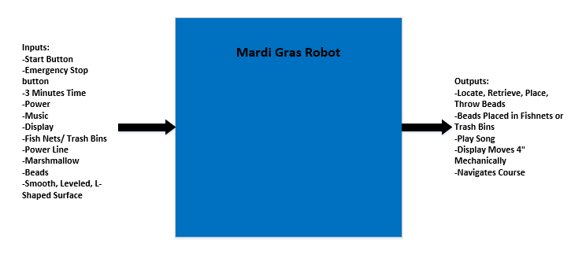

Figure 2. Level 0 System Diagram

System Specification: A competitive*, safe system costing no more than $4000, designed and constructed before the IEEE Hardware Competition, fitting in a 1' x 1’ x 1’ box, that when activated by a start button, autonomously locates, retrieves, places, and throws 20/30/40 beads into fish nets and “trash bins” from a 4’ x 8’ area. It will pass under a “power line” and push a marshmallow off the L-shaped roadway. All tasks will be done within a 3-minute time period.[9]

### Process Model Flow Chart

In order to ensure coverage of the system’s functionality a process model flow chart of the hardware contest was developed. It is shown below in Figure One.

Figure One. Process Model Flow Chart

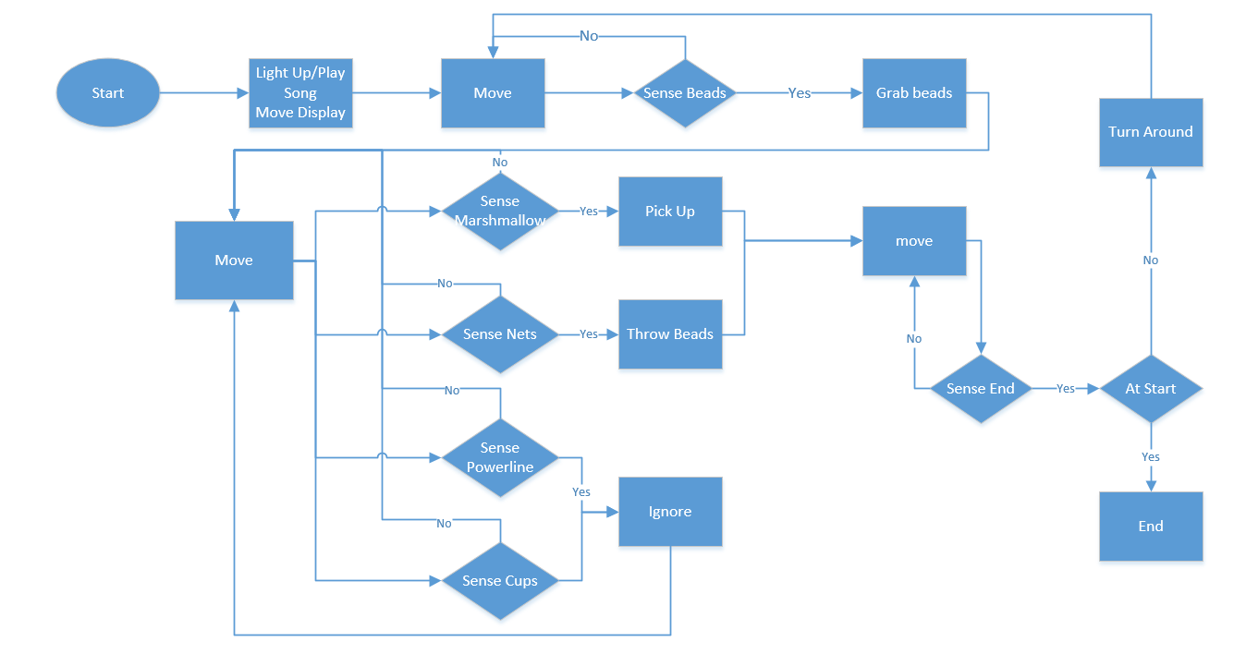

Figure 3. Process Model Flow Chart

Note: The ignore function is included due to the strategy that our Team is employing and the physical build of our robot in relation to the board. For the powerline we are afforded 21’’ of clearance with our robot only having a height profile of 12’’ while moving. For the cups, our Team has decided our efforts would be better spent to target the nets rather than the cups to maximize points.

## The Level 1 Subsystems View

The Level 1 view enhances the Level 0 representation by showing the subsystem's functionality of the system. It contains the actions identified by the process model and further details derived requirements extending throughout the system like control and power functions. Although not explicitly detailed in this representation, the fact that all the subsystems are contained in a box implies that the system is an integrated entity.

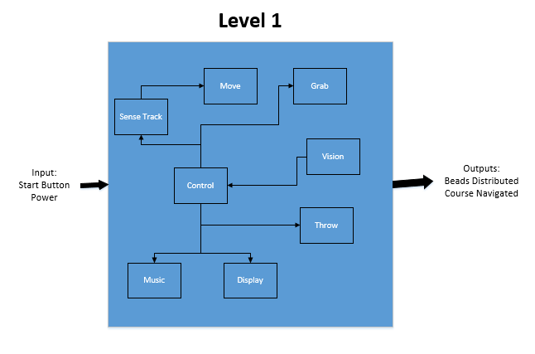

Figure 4. Level 1 Subsystems Diagram

Level 1 subsystem functions include sense the track, move, vision, grab beads, throw beads in nets, play music, move screen.

* Sensing the Track involves using line following sensors to identify the white line on the game board. This sensing function is integral to the precise movement of the robot without running into any walls or obstacles on the game board.
* The Move function uses the information from the sensing function in order to drive the motors accurately and precisely. The movement of the robot will be necessary to navigate the course and align the robot to both grab beads and throw them into nets.
* The Robot’s Vision function will utilize computer vision to locate beads on the trees before grabbing them. Since the beads and nets can be in random positions on the game board, a vision function is required to locate them before the grabbing and throwing functions can be utilized. The vision function will also work hand in hand with the movement function in order to align the robot with both trees and nets before grabbing and throwing.
* The Grabbing function will be used to grab the beads off the trees and store them on the robot before throwing them into a net.
* The Throwing function will be used to throw the stored beads into nets while navigating the course. Vision will be essential for both the grabbing and throwing functions.
* The Play Music function will operate on its own without interacting with other functions. The robot will play music as it navigates and completes the course.
* Similarly, the Move Screen function will operate independently. As the robot navigates and completes the course, a small LCD screen will move in multiple directions. The play music function and move screen function are required to secure some extra points in the competition and will not interact with the robot’s more complex functions.

## Level 2 Subsystem Breakdown or Component level views

|  |  |  |  |  |  |
| --- | --- | --- | --- | --- | --- |
| **Recover / Derived Rat** | **Control** | **Hardware** | **Interface** | **Power** | **Timing (sec)** |
| **Start neutral position** | **Verify neutral, if not recover** | **Sensor(s), tilt, V&H move** | **Control, sensors, V&H move** | **Control, sensors** | **0.1 / 4** |
| **Receive recover signal** | **Can sensed, move stopped** | **Control, move** | **Move, control** | **Move, control, retrieve** | **0.1** |
| **Lower clam** | **Lower to limit stop** | **Lower, stop sense** | **Control, clam lower stop sense** | **Clam lower move, control, sense** | **0.5** |
| **Pull Clam** | **Pull to limit stop** | **Pull, stop sense** | **Control, clam pull limit stop** | **Clam pull move, control, sense** | **0.9** |
| **Elevate clam** | **Elevate to limit stop** | **Lift , top sense** | **Control, lift limit stop sense** | **Lift, control, sense** | **1.9** |
| **Tilt clam** | **Tilt to limit stop** | **Tilt , limit sense** | **Control, tilt limit sense** | **Control, tilt, sense** | **0.5** |
| **Recover to neutral** | **unTilt, lower, extend to neutral** | **unTilt, lower, extend, limit sensors** | **Control, tilt, lower, pull, move, sensors** | **Control, tilt, lower, extend, sensor** | **3.8 = .5 + .9 + 1.9 + .5** |
| **\*\*Notes\*\*** | **Extra cycle if not recovered** | **V&H move, tilting, limits sensors** | **Power separate** | **10 cycles ~ 24 Joule each (est. attached)** | **10 cycles ~ 8 seconds each (see control note)** |

Level 2 focuses on the individual subsystems. It focuses on the control, inputs and outputs of each subsystem as they pertain to the overall design of the robot.

### Vision Function

The vision function scans the playing board for objectives such as beads, and nets. The vision function utilizes computer vision to identify and track these objects. The outputs of the vision function are interrupts and command signals that are then sent to other subsystems to achieve an overarching action such as stopping the robot, initiating the grab or throw function, and so on.

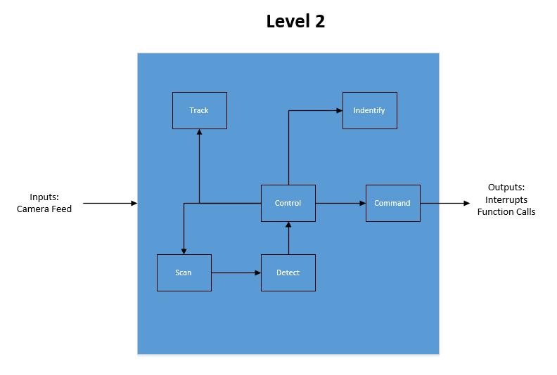

Figure 5. Level 2: Vision Function Diagram

Allocated performance for the vision function: The camera is mounted to the top of the robot. This is then used to identify the beads, marshmallow, and the nets. Once the camera is aligned with the detected object it the function sends an interrupt to the drive train to stop. Depending on the object that is detected the function will initiate a function to either retrieve beads, throw beads, or pick up the marshmallow. The vision function needs to be able to accurately detect, differentiate and track multiple objects in order to determine the appropriate outputs to the rest of the system. The vision function is also required to operate within real time to ensure accurate data and prompt action is taken during these events.

### Grab Function

The Grab Function is initiated by the Vision Function. It starts when the vision identifies the pole where the beads are residing. Once identified it will stop the drive train and extend the arm on the robot to pick up the beads. The outputs of the function are beads that are secured from the poles and a signal to the main controller to carry on once the operation is complete.

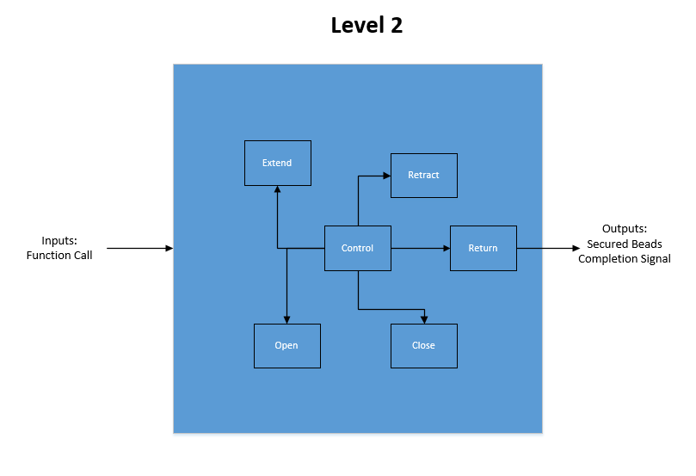

Figure 6. Level 2: Grab Function Diagram

Allocated performance for the grab function: The arm being used to grab the beads is folded on the robot initially to allow for the one cubic foot size requirement. When the vision identifies the pole, the arm unfolds and extends to the known location of the beads. It will open the grabbing mechanism and close around the beads before retracting and returning to the starting position. This function will be used only to retrieve the beads. As a team it was decided that attempting to put the beads in the bins is not worth the effort when nets are considered a more point effective strategy. For this reason, the arm will only be required for use at the beginning and end of the track where the two poles reside with the beads.

### Throw Function

The Throw Function is initialized by the Vision Function. This function is used to throw the beads from the robot into the nets, gaining points for the team as the robot completes the course. The outputs of this function are the beads dispersed in the nets, and a signal to let the robot continue the course upon completion.

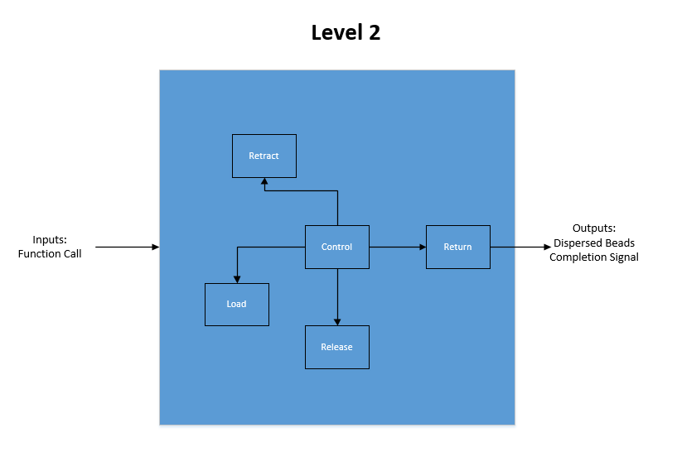

Figure 7. Level 2: Launcher Function Diagram

Allocated performance for the throw function: The throw function will utilize the launching mechanism of the robot. This mechanism will be mounted on the top on a rotating base. With the aid of the vision function it will deliver the beads from the robot to the nets. The throw function will always launch the beads to the right of the robot with respect to the direction in which the robot was traveling before it stopped. This is to reduce complexity in the design requiring the top to constantly pivot as the robot traverses the course rather than simply once at the end. The function will be responsible for launching the beads a minimum of four inches into a net with an eight-inch diameter target window.

### Block Diagrams - Component Level

Below are block diagram functions for the high-level Mardi Gras Robot components, with further diagrams to include the Arm, Drivetrain, and Launching mechanism.

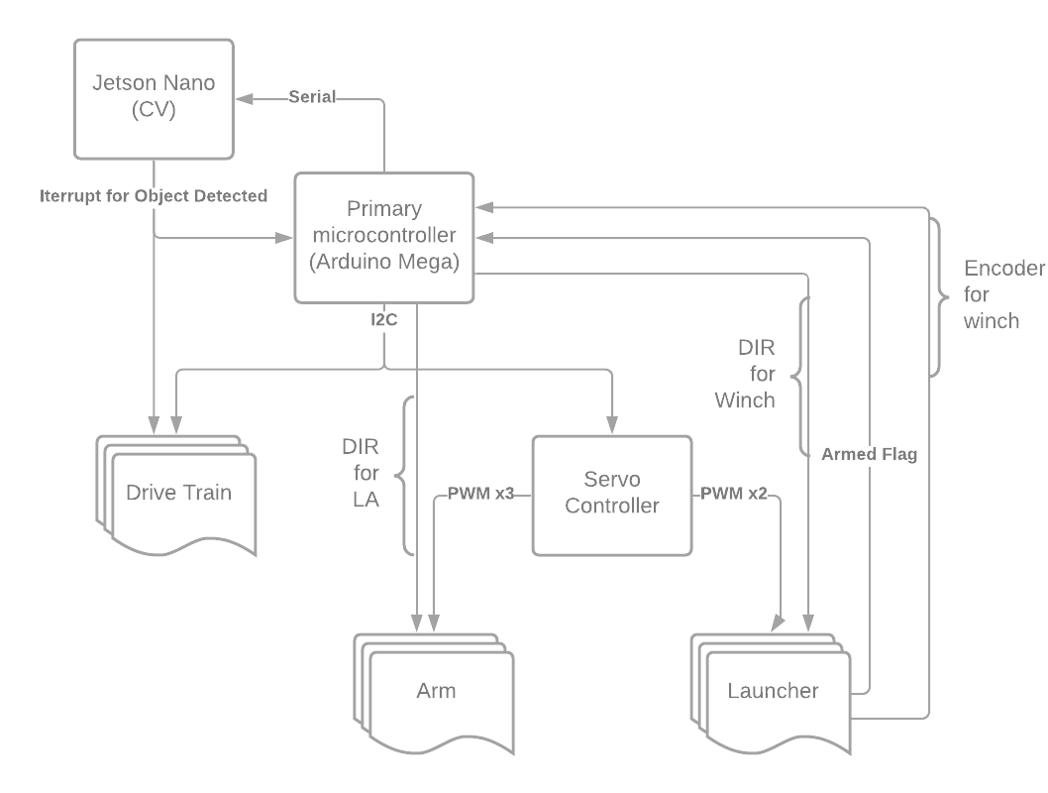

Figure 8. Block Diagram for the Robot

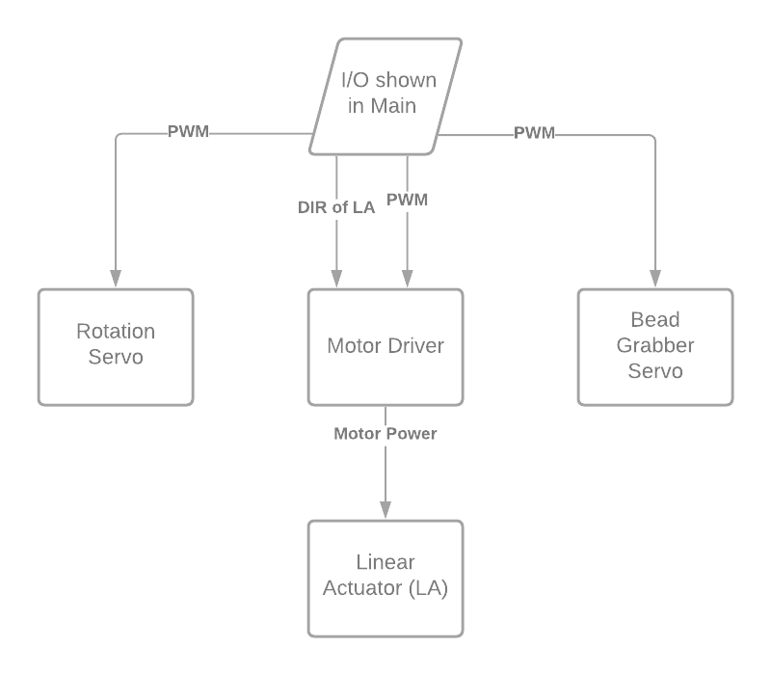

Figure 9. Block Diagram for the Arm

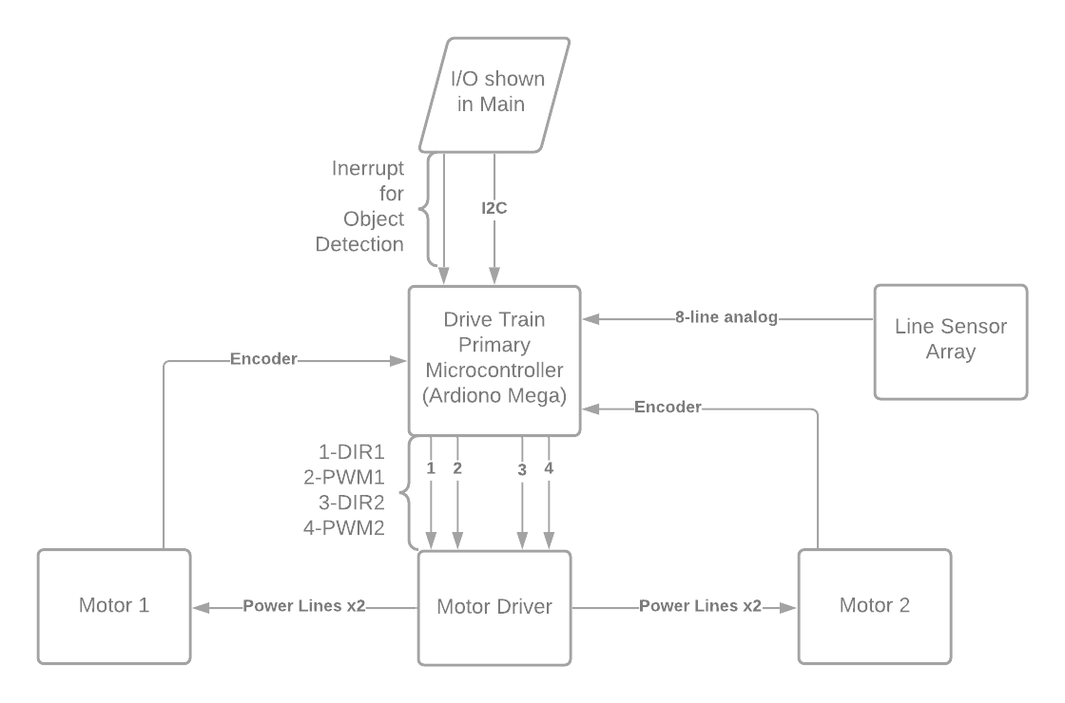

Figure 10. Block Diagram for the Drivetrain

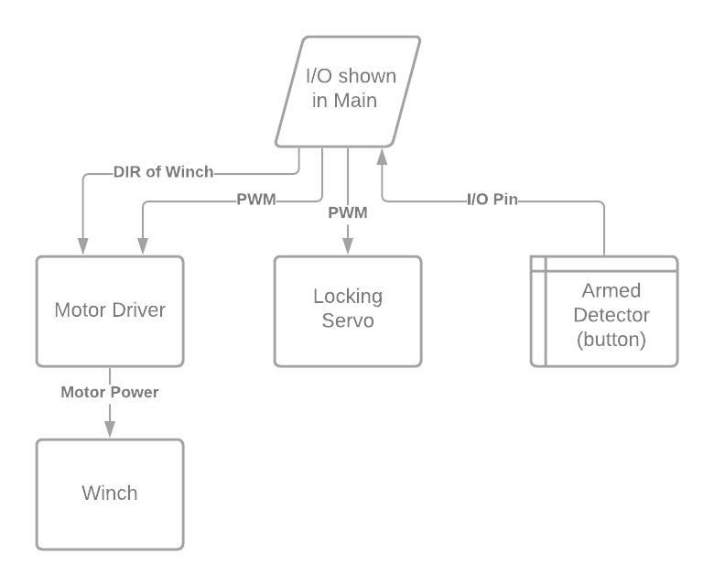

Figure 11. Block Diagram for the Launcher

# Analysis of Alternatives

The alternative design section discusses some of the alternative designs proposed and examined by the design team. If no alternative designs were examined, the team could not deliberate which is the best design. This section will discuss some of the design alternatives explored for major parts of the robot to include point strategy, the software package, the bead retrieval method, the bead launching mechanism, LED screen that moves, the shape and drivetrain of the robot, microcontroller, as well as another arm design.

## Overall Strategy

The point strategy shaped the direction of the robot build, changing the research, design, and implementation that took place. The teams met, discussed the best method to score points, paving the way forward for the robot. One of the strategies that the teams discussed was to ignore the nets and only place the beads in the cups. Another course of action included only going for the nets, and not the cups. However, using the computer vision software we have decided that it would be possible to retrieve the beads and place them in both the cups and nets. The different point strategies were discussed and drawn out on the chalkboard and ways to attack the “low hanging fruit” by keeping systems independent of one another to maximize the points. The point breakdown is depicted below[10], with an analysis following.

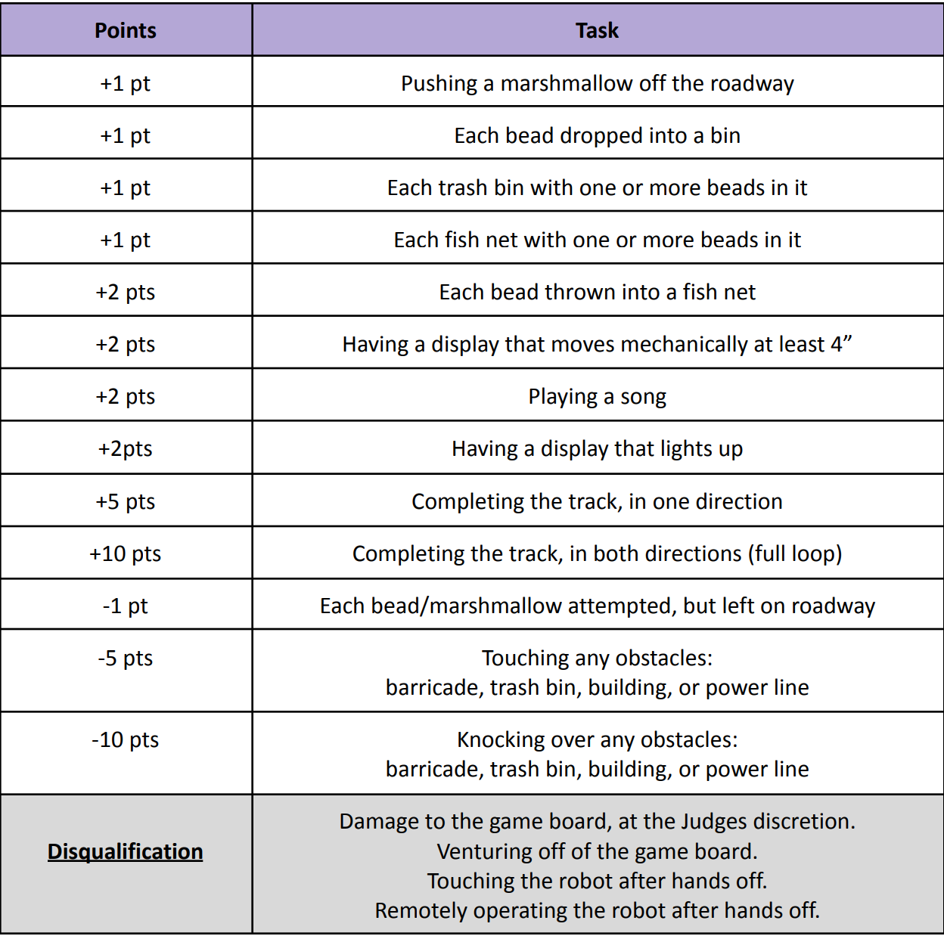

Table . Competition Point Breakdown

As a team, we decided to go with the route of throwing the beads into the nets instead of placing the beads in the cups as we would only need 50% accuracy with the nets and 100% accuracy with the cups to match the number of points scored by the two methods as depicted in the scoring breakdown of the rules competition in the above figure. The point breakdown depicted above also shows the effectiveness of achieving the “low-hanging fruit” such as the: display that lights up, playing a song, and moving a display four inches. These are considered easy points due to their simplicity and ease of adding them to the system without causing major changes (i.e. does not interfere with arm or launcher subsystem). It is effective to achieve these easy points as they can be added to the robot with the least amount of integration effort while making these points guaranteed. These “low-hanging fruit” are the points that we should still achieve assuming the worst case scenario of the robot failing.

## Robot Systems Evaluation Cirteria

When determining which component or software to use for a subsystem, the Analytical Hierarchy Process (AHP) adds objectivity to the selection of alternatives. The first step is to determine evaluation criteria that are relevant to the system level. Those associated with the conceptual view would represent marketing and user criteria. Those linked to a subsystem or component will be more closely governed by engineering considerations. These criteria are then weighted using a pair wise comparison. Next the alternatives are individually rated against each criterion then scored to place them in rank order. The last step is to review the decision. This technique is also used to evaluate strategic approaches that inform the overall system design.

### Computer Vision Evalation Cirteria

* Time to Train
* Documentation
* Interface

### Controller Evaluation Criteria

* Timing
* Ease of Programming
* Power

### Drivetrain Evaluation Criteria

* Precision of Movement
* Maneuverability
* Simplicity

## Establishing Criteria Intent

### Computer Vision Criteria Intent

* Time to Train: Want to minimize time spent training the AI to detect the fish nets
  + Too much time spent training can put the team behind schedule and be detrimental to overall progress
* Documentation: Want maximum amount of documentation on computer vision software to make creation easy as possible.
  + Good documentation allows problems to be overcome effectively as well as keep track of progression throughout the process
* Interface: Want intuitive interface for easy interaction and lower probability of errors made.



Table , Computer Vision Criteria Intent

### Controller Criteria Intent



Table , Controller Criteria Intent

### Drivtrain Criteria Intent

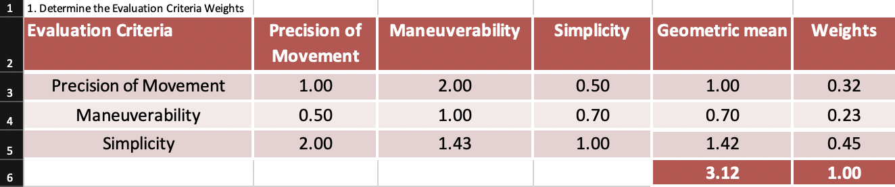

Table 8. Drivetrain Criteria Intent

## Defining Alternatives

### Computer Vision Alternatives Definition

* OpenCV: an open-source library for real-time computer vision solutions
* PyTorch: an open-source machine learning library that can be used for a variety of applications such as CV and NLP
* TensorFlow: an open-source machine learning library with a focus on training and inference of deep neural networks



Table . Analysis of Time to Train



Table . Analysis of Documentation



Table . Analysis of Quality of Interface



Table . Combined rankings and final ratings

### Controller Alternatives Definition



Table , Analysis of Timing



Table , Analysis of Ease of Programming



Table , Analysis of Power Consumption



Table , Combined and final Rankings of Controller criteria

### Drivetrain Alternatives Definition

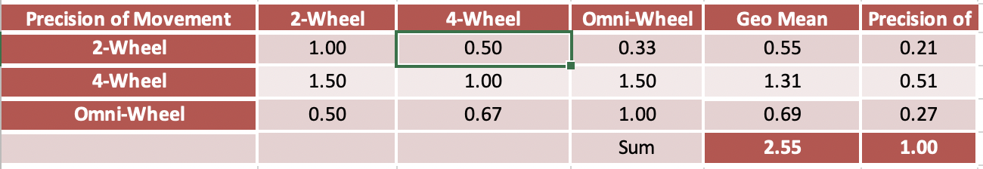

*Table 9. Analysis of Precision of Movement*

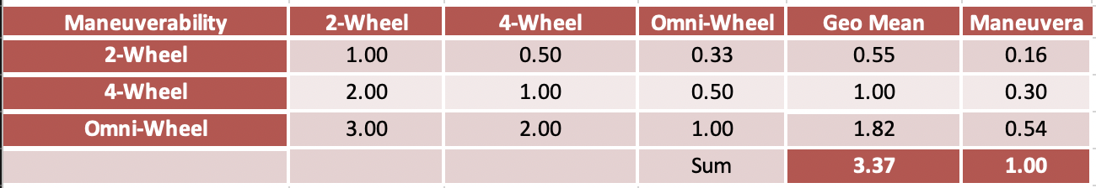

*Table 10. Analysis of Maneuverability*

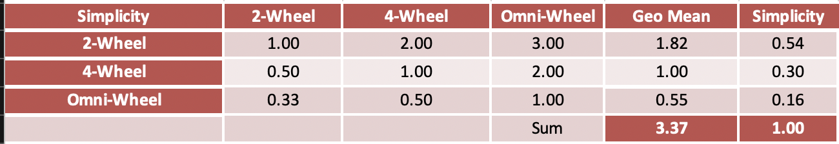

*Table 11. Analysis of Simplicity*

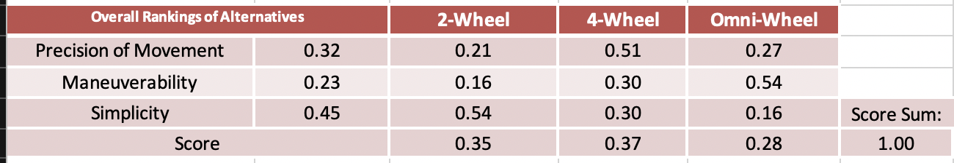

*Table 12. Combined rankings and ratings*

## Decision Review

### Computer Vision Decision Review

* OpenCV ranked highest in every Ranking. This will be our preferred choice of CV Software
* PyTorch preferred over TensorFlow, where it lacks documentation, it scores better in Time to Train and Interface. This will become our secondary option should OpenCV prove not viable.
* TensorFlow scored the lowest in both Time to Train and Interface, it could still possibly be used but only if OpenCV and TensorFlow prove not viable.
* These scores are semi-quantitative and based off the Software Team’s initial impressions of the Software produced from research.

### Controller Decision Review

* The three controllers compared were the Arduino Mega, the Jetson, and the Distributed
* The Arduino Mega scored the highest in the power category
* The Jetson scored the highest in ease of programming
* The Distributed power was chosen on

### Drivetrain Decision Review

* The 2-wheel setup was highest in the category for simplicity.
* Omni-wheels were suggested but provided a high risk of slippage while the robot is in operation.
* The 2-wheel setup will be paired with casters to overcome any alignment and balance challenges that the 4-wheel setup would provide as an advantage.
* The 2-wheel setup is the final decision for the drivetrain due to its simplicity compared to the other options. The 2-wheel setup can complete the task without the added complexity.
* The Omni-wheels and 4-wheel setup would require twice the time to interface due to its demand for more moving parts.

## Further Discussion of Design Alrternatives

The bead retrieval system went through several iterations of design before reaching the design the team is currently assembling. Although constructed to a partial prototype, this design of the arm was scraped vice a linear actuator arm with a three-dimensionally printed mount. The team had limited it down to two designs, the first includes a three-piece arm that consists of two segments of arm and a 3-D printed pole to slide the beads off the “tree.” The second design consists of a linear actuator which extends orthogonal to the robot with a similar pole to retrieve the beads. The biggest design challenge the team faced with the retrieval mechanism included the height of the tree relative to the size limitations of the robot. The cost of this retrieval mechanism also had to be cheap, while maintaining a fast-paced schedule, and still being able to successfully retrieve the beads off the tree. The construction and maintenance of the arm must be quick and maintainable to allow the team to be successful in scoring the most points in the competition. The first arm seen below was in the final stages of a prototype build, while the second arm is now constructed and almost integrated with the chassis of the robot. The cost, schedule, and possible performance of the linear actuator (second) arm pales in comparison to the first arm design at the current stage. Furthermore, the arm is controlled by three servos that rotate the base of the arm, elevation of the arm, as well as the angle of the end “pole” retrieval mechanism. The rough prototype built for this robot is still in stand-by if need be, however the linear actuating arm is the decision the team went with for now.

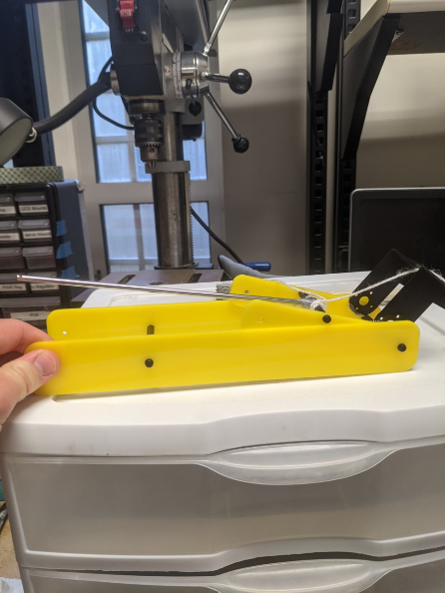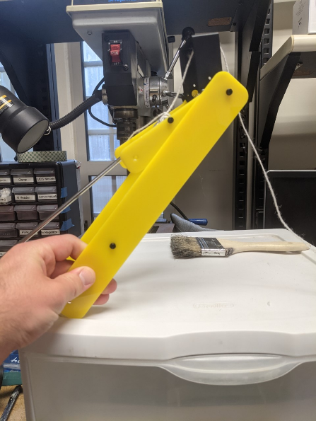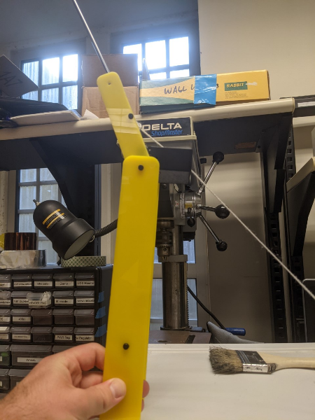

Figure 12. Bead retrieval mechanism proof of concept.

The launching mechanism has also gone through different iterations in the design stage as throwing beads into nets offers more points than just finding and placing beads in just the cups alone. Currently, the launching mechanism is set to be a catapult-like launching mechanism that launches beads into nets. The performance of the launching mechanism just must be over 50% effective to offer better return than an arm that places beads in every cup that is sensed and successfully achieved. The prototype of the catapult is depicted below, where the beads will be placed in the “cup” and launched with the release of a motor and the tension of the “bungie cord” will then contract and fling the beads into the net.

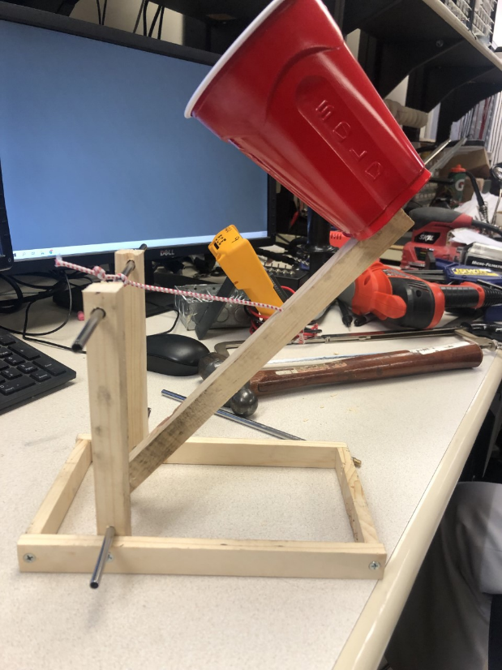

Figure 13. Bead launching mechanism proof of concept

The required light up display also has a variety of options that were analyzed, with the current design to be a small LED screen that has a micro-SD card that displays an image (or variety of images). The cost of this LED display allowed for a cheap, mini display that checked the box of a light up and versatile display without affecting the performance of the robot, nor a major schedule inhibitor. The other options explored included a design with a ribbon cable, which did not have good documentation or an interface that had been used by any of the team members before. Also, the light up display has a requirement to “move” four inches. The current course of action is to have the LED display as a separate unit than other moving parts such as the arm and the catapult. The reasoning behind this is when it comes to implementation, the arm, or another unit of the robot may fail at the competition. The current plan is to acquire a small linear actuator that has a horizontal displacement of two inches so the screen can travel a total of four inches with just one iteration. An alternative solution is to put the light up display on a rotating servo and have it displaced four inches over the course of the rotation.

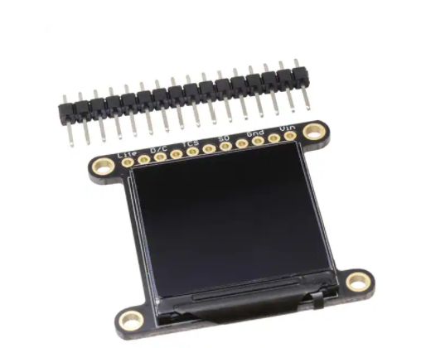

Figure 14. Example of OLED Display

The arm design that used the linear actuator was initially the alternative since the arm is arguably the most complicated subsystem of the robot. This actuator has a 3D-printed mount attached to it at roughly the same height. There would be a rope anchored to the chassis of the robot and attached to the mount over the linear actuator. As the linear actuator would extend out, the mount would go up twice that distance. After that, a rigid material would be extended out from the top of the mount through the first of two mini servos to make the beads fall to the bottom of the wire. There would be a mini cone placed to catch the beads once they have slid partially down the arm. Finally, the second of the two mini servos would rotate to the side of the catapult mechanism and the rigid extension would then tilt forward to allow the beads to fall into the launching mechanism. Both designs of the arm belong in the alternative arm design portion because they were built in parallel to satisfy the requirements of the robot. The initial arm that was prototypes could still be replaced for the current arm with the linear actuator. In terms of alternative arm designs, the arm subsystem is the most substantial in this project.

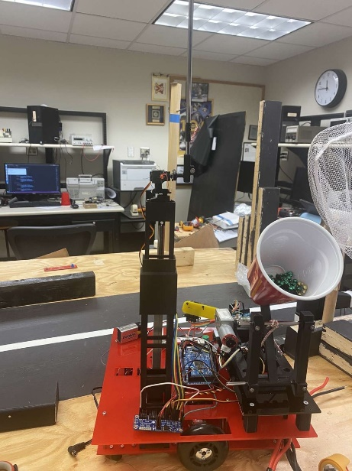

Figure 15. Linear Actuator Arm

The drivetrain of the robot could be a “track” design, omni-wheels, or regular wheels. The design we chose included a regular wheelbase for the following reasons: simplicity, price, versatility, as well as familiarity with the design. There are plenty of drivetrains, motors, and screws to build the plain design without leaving the laboratory. Also, the drivetrain was chosen to have two wheels instead of four due to the reduction and minimalization of design and programming. The other options included a three-wheel drive, four-wheel drive, and a track driven design. The drivetrain consisted of two wheels mounted in the centers with casters at all four corners for stabilization and ease of maneuverability.

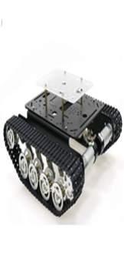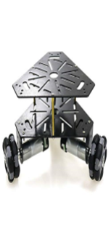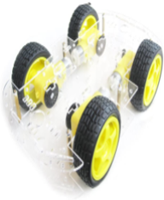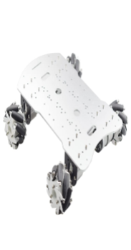

Figure 16. Examples of prefabricated drivetrains

A microcontroller is also a large decision maker of the kinds of electronics that we purchase. The current design is to limit the servos and the GPIO required for the robot to meet the requirements of the hardware design competition. The current microcontroller being used is the Arduino MEGA. The other microcontrollers analyzed include the Arduino UNO, Raspberry Pi, ESP-32, as well as the TI MSP430. The MEGA has the required GPIO that is required of the proposed system, as well as familiar interfacing with the Arduino IDE environment.

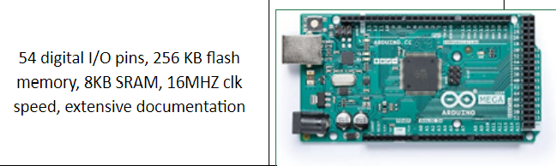

Figure 17. Arduino Mega

# Synthesis

Design synthesis is the process of selecting the physical components which satisfy the system’s functional capabilities that are identified during functional decomposition. Synthesis transforms the functional architecture represented by the decompositions into a multilayered physical architecture. To ensure coverage of the systems functions, a Functional /Physical Matrix is often used to map each system functionality to a corresponding physical element selected to perform the function. This selection is reinforced by the analysis of alternatives which narrowed down technological approaches to satisfy the system’s functional needs. The physical architecture of the system is represented by the product side of the WBS.

## Functional/Physical Matrix



Figure 18. Physical Matrix

Design Synthesis principles include:

* Standardization: controls, displays, marking, labeling, coding, arrangement schemes should be uniform for common functions
* Simplicity of design: simplest design meeting functional requirements and expected service conditions
* Fail-safe design: Fails “gracefully” avoiding catastrophic damage to equipment or injury to personnel
* Interaction: aids human to hardware/software interface
* Safety: design reflects system and personnel safety factors
* Open Systems: use of standards to aid tech evolution, ease of manufacture, reliability

## System schematic block diagram

This block diagram gives a basic overview of the major subsystems and how they interact with the robot and are powered.

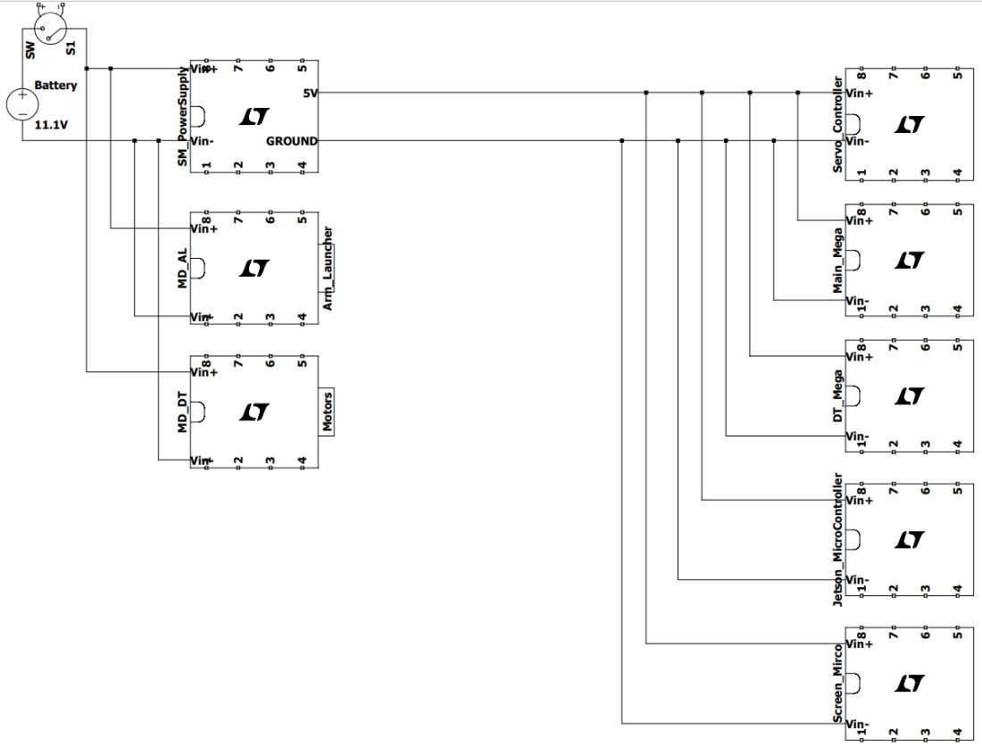

Figure 19. Power Schematic Block Diagram

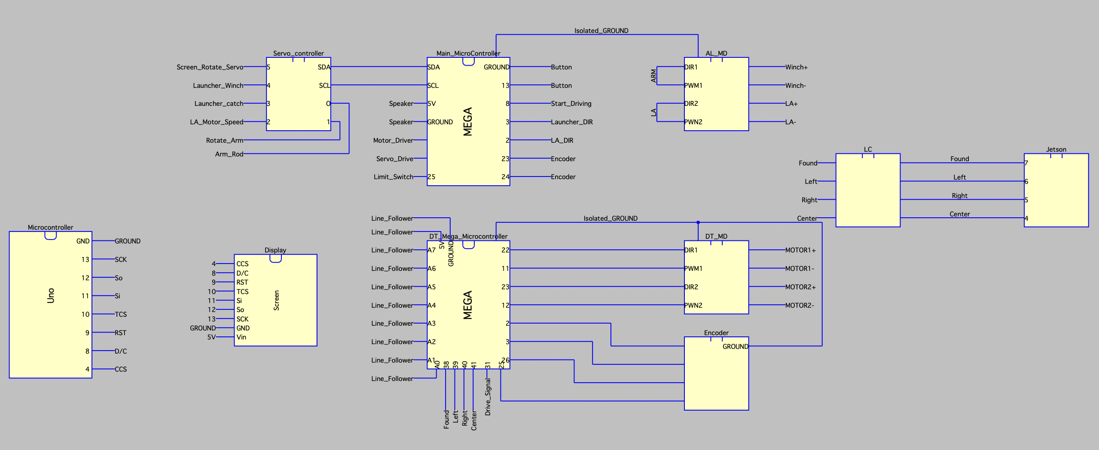

Figure 20. System Communication Block Diagram

## System Design Analysis

A technical explanation of the system. (why/how the product works and if it meets specifications; references materials in technical data package like system diagrams, schematics, photos of the system, parts breakdowns, drawings, software design information, source code, technical product notes, hardware component data, users’ manuals, quick start guides, etc.) For EE421X this is just a simple explanation of how you envision the robot completing the task required by the contest rules.

### Software System Design Analysis

*Computer Vision Code:*

After analyzing different repositories and software for object detection/computer vision that is compatible with the NVIDIA Jetson, “Hello AI World” an "inference and real-time Deep Neural Network (DNN) vision library for the NVIDIA Jetson Nano” was chosen.[11] It supports both pre-trained and trainable models for object classification and detection using “NVIDIA TensorRT for efficiently deploying neural networks onto the embedded Jetson platform, improving performance and power efficiency using graph optimizations, kernel fusion, and 16-bit floating point (FP16/INT8) precision.”[12] Based on this and the features included, this inference provides easy-to-use commands, relatively fast training time, and open-source code that can be modified for hardware interaction.

So far, it has been manually trained for the net and cup using over 500 images. When close to what the robot will see on the game board, the cup and net are detected with over 90% accuracy as seen in Figure 19.

While running a live feed around 40 frames per second (FPS) and a single Mobile Industry Processor Industry (MIPI) camera setup, the dimensions, coordinates, and inference are calculated in 25-35ms as seen in Figure 21. By using the coordinates of the object, the source code, and general-purpose input/output (GPIO) pins, the NVIDIA Jetson will be able to send signals to the other components once objects are detected. Current testing to achieve this is setting up alignment flags based on if a net is to the left or right of the center screen. The robot will then adjust accordingly to line-up to the center of the object.

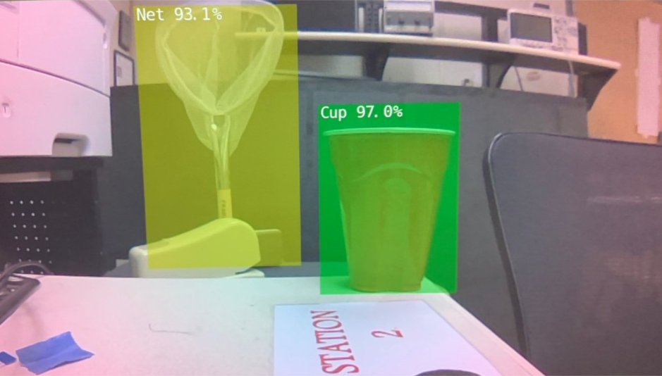

Figure , Early stages of the system analyzing the net and red solo cup that will be used in the competition

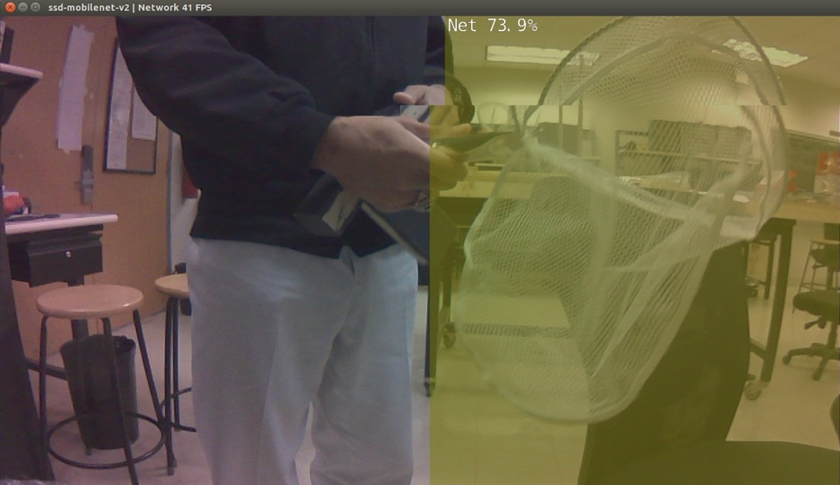

Figure , Net that is being moved around and detected

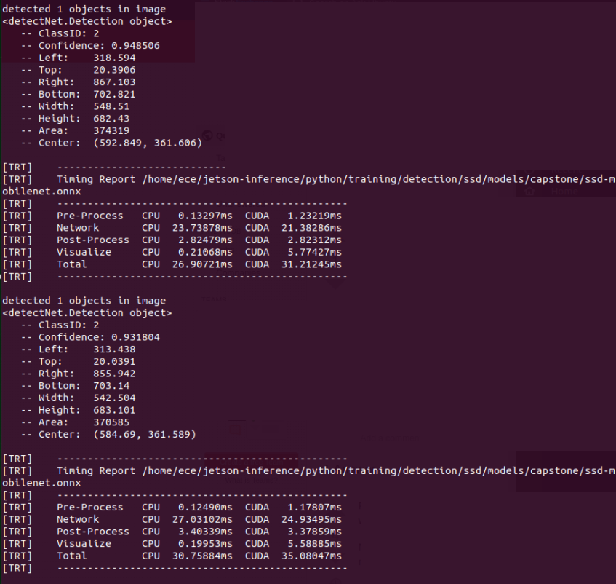

Figure , Object detection runtimes

The largest time-consuming task right now with computer vision and object detection is the need for an extensive number of pictures to train the model and the time it takes to train. To be sufficiently trained, which is defined as 90% accuracy in multiple orientations, lighting, and backgrounds, it will take an estimated 1000 pictures total. As the number of images increases, the time to train increases. As of now, it takes approximately 50 seconds for each epoch to train 257 images. Training for 30 epochs, which is where training accuracy plateaus as seen in Figure 22, currently takes ~25 minutes but may reach ~100-120 minutes when at 1000 images.

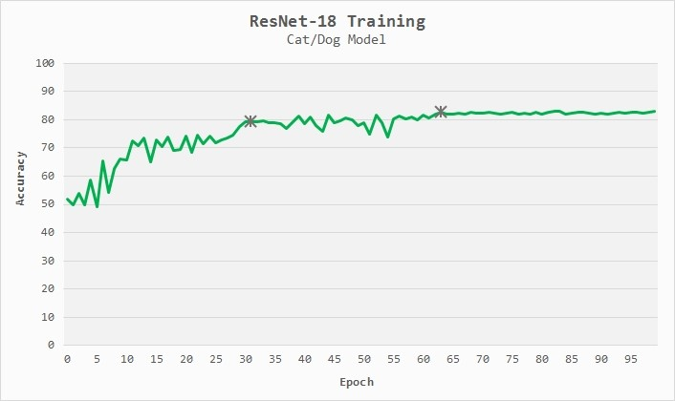

Figure , Accuracy/Epoch Graph for Detection Training

Throughout development, changes that have been made to the Compute Unified Device Architecture (CUDA) code that affects the appearance of what is outputted by the computer vision software as seen in Figure X. The code now has CUDA draw a rectangle around the object instead of a translucent rectangle covering the object. When the object is not in the center of the screen one of the sides of the drawn rectangle is changed to the color red. The side that is changed highlights which direction the camera needs to travel to realign the object with the center as demonstrated in the below Figures. Once implemented onto the target zone for alignment will be changed to fit with the mounted position of the camera. Changing the color of the sides of the bounding box will allow for easier debugging and maintenance once the computer vision is implemented onto the robot.

To handle the issue of seeing multiple objects at the same time through the camera while on the gameboard, there is a current solution being worked on. Since cups are ultimately being ignored for the competition, the main focus of computer vision is poles with beads and nets. There will be a global variable in the code that keeps track of whether the catapult is loaded with beads or not. If the robot currently has no loaded beads, computer vision will only detect and interact with poles that have beads attached while ignoring any nets. Once the beads are grabbed, the software will ignore all poles and only focus on detecting nets to be shot in.

Since poles and nets have a similar wooden base, the idea is to only train with images of poles containing beads. That way, there will be more distinction between the poles and nets in terms of detection. Additionally, poles without beads should not be detected due to this which is ideal since the robot will not need to interact with empty poles at any time.

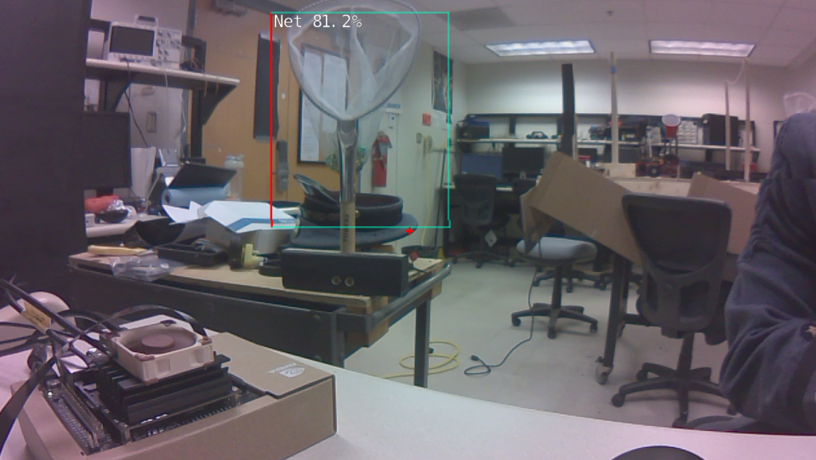

Figure . Net located to the left of x-axis center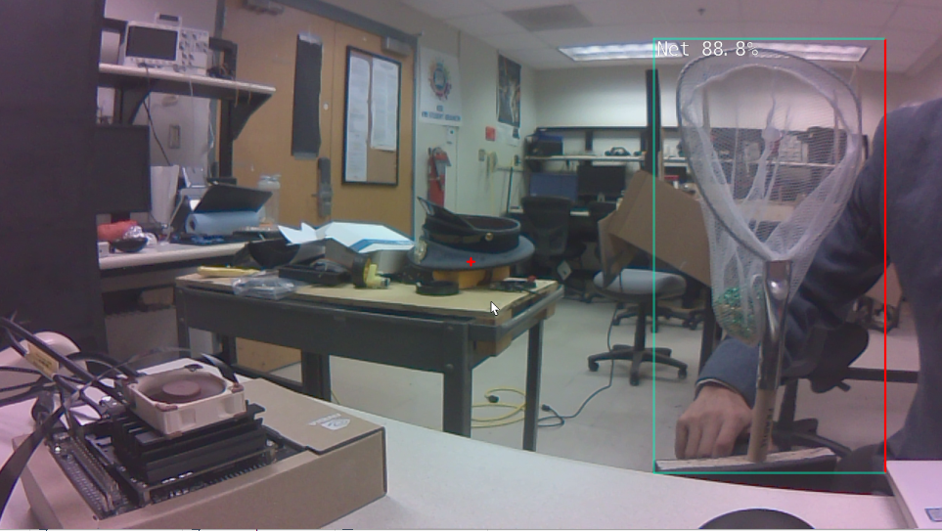

Figure . Net located to the right of x-axis center

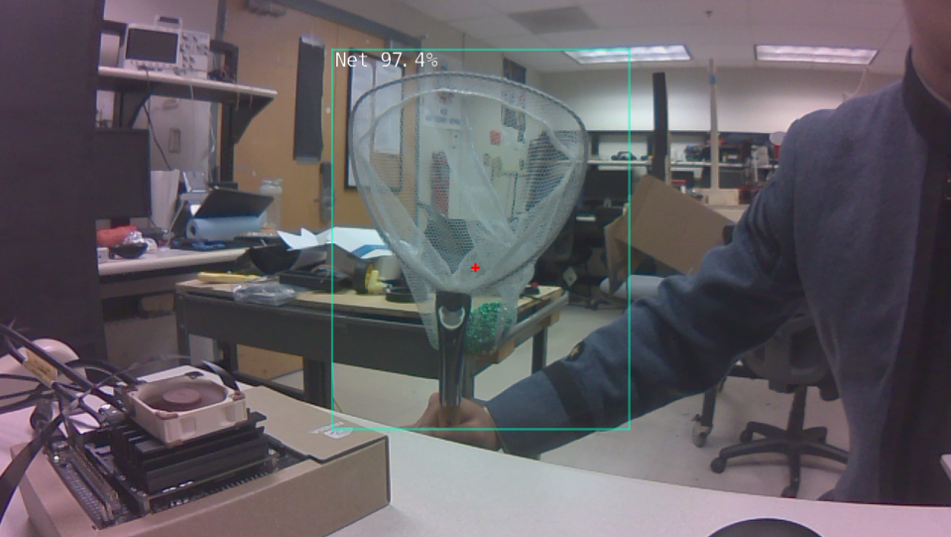

Figure . Net centered on the x-axis of the camera

### CAD Progression

When designing and building specific subsystems, it is important to ensure the design is physically possible to build, based on the 3-Dimensional constraints. So far, there has been pre-build render utilizing 3D CAD software such as SolidWorks™ to iron out the details of the build (example of render shown below in Figures 27 & 28). This helps with selecting parts and then projecting them onto the 3D prototype to check for physical obstructions. The robot so far has been vastly helped by utilizing CAD to fully build the robot and ensure spatial requirements and logic errors when building is avoided. The robot shown below in Figures 27 & 28 is slightly ahead of the normal build, and has some issues fixed to ensure when the newest revision is ready to be built, the hardware aspect is already taken care of. Some issues that have been fixed in the newest revision include Arduino mega holes are better aligned, the location of standoffs have been fixed to allow for cords to travel easier, and the arm hole for the second layer has been adjusted to take tension off the first layer. As it stands, the robot is nearly completed in the CAD model, the only additions necessary are the camera for computer vision, the servo mount for the display servo, and the servo controller.

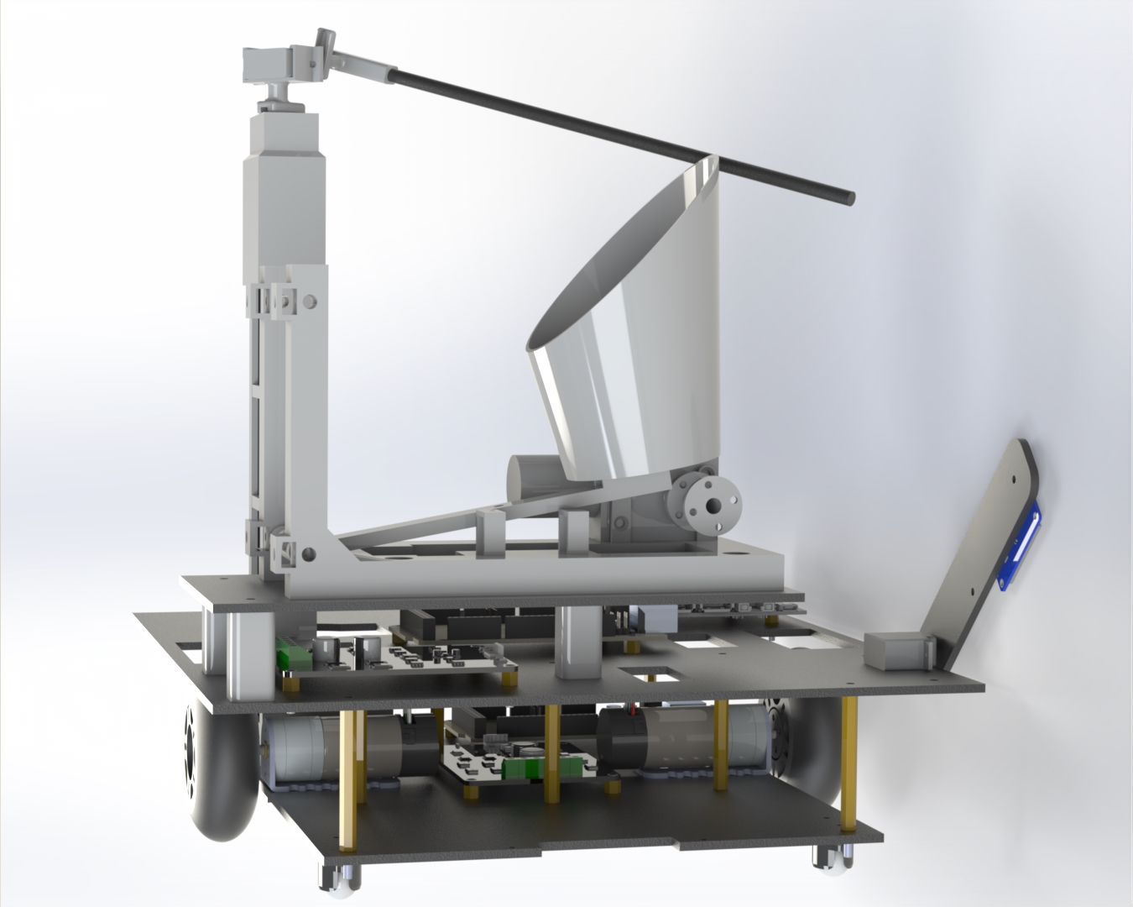

Figure . Current CAD Progress as of 12/13/2021 Angle 1.

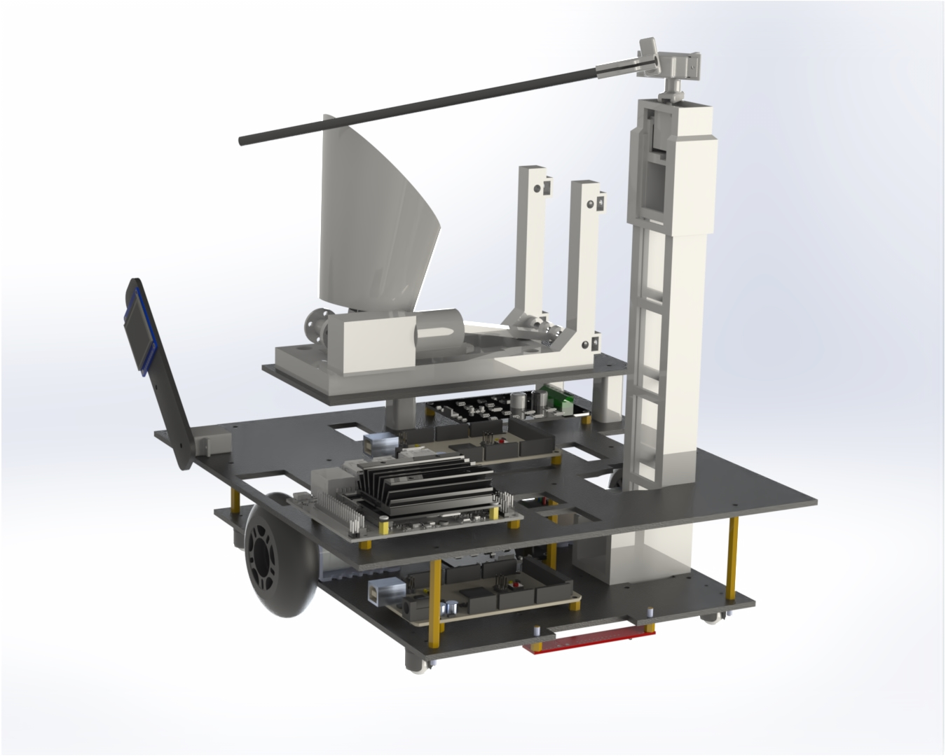

Figure . Current CAD Progress as of 12/13/2021 Angle 2.



Figure 29. Current CAD Progress as of 12/13/2021 Angle 3.

### System Viability

*Proportions:*

The designed proportions of our robot are to be within the 1’ cubic square restriction, the robot’s length and width are currently 11’’ x 10’’ and are not projected to increase. The decision of these proportions was to allow for our robot to have ample room to drift on the board and for the sharp turn while not coming into contact with the walls of the track.

*Drivetrain:*

The drivetrain is in the refinement stage as of this document. This part of the system is capable of tracking the line down the board and handling the turn. In its current stage the program for the drivetrain is rigid. This was done for testing purposes to find the appropriate processes for individual situations on the board. With this knowledge the code will be refined to make it more adaptable with improved functions and efficiency.

*Display and Sound:*

This system is not necessary for the functionality of our robot. Its purpose is to provide us with the extra points associated with it. Currently the progress of this system is fully functional and consistently achieves points. The electronic team was able to display 240 pixel by 320 pixel VMI logo on a 1.5 inch screen with the ability to move 4 inches as well as produce a noise by using a little speaker that was repurposed from a small toy. However, the team will still develop the system to display more pictures and play songs related to the institute, VMI.

*Computer Vision:*

This system is currently in training. The Software Team is underway to having the system recognize the various obstacles and elements of the board. At this time, it is trained to recognize the nets and cups. Once fully trained the system will allow the robot to detect the bead poles and nets; and align the arm or launching mechanism accordingly.

*Launching Mechanism:*

The launching system is in the programming stage. The Hardware team has prototyped a launching mechanism using the basic idea of a catapult with some added features for consistent, precise, and accurate shots. The design is fully functional and can shoot beads into the net accurately via hand manipulation of the catapult, just needs to be programmed and tuned. Once programmed and tested, the launching mechanism will be able to fit the 1’ cubic square restriction and shoot beads in the nets accurately.

*Grabbing Mechanism:*

The arm is currently in prototyping by using 3-D printed poles for one of the designs and laser-cut acrylic for the second. The Electronic team is designing an arm that allows the robot to extend an excavator like arm and grab beads with the ability to rotate itself to place beads in the catapult and be ready to launch to the nets. Also, the design fits in a 1’ square robot. The second team has built a crane-like arm that is able to raise itself using a linear actuator and 2 degrees of freedom at the top of the arm to allow for Y&Z directional capabilities. Once completed, the arms will be able to coordinate with the computer vision to detect a pole, grab the beads, and place them within the catapult.

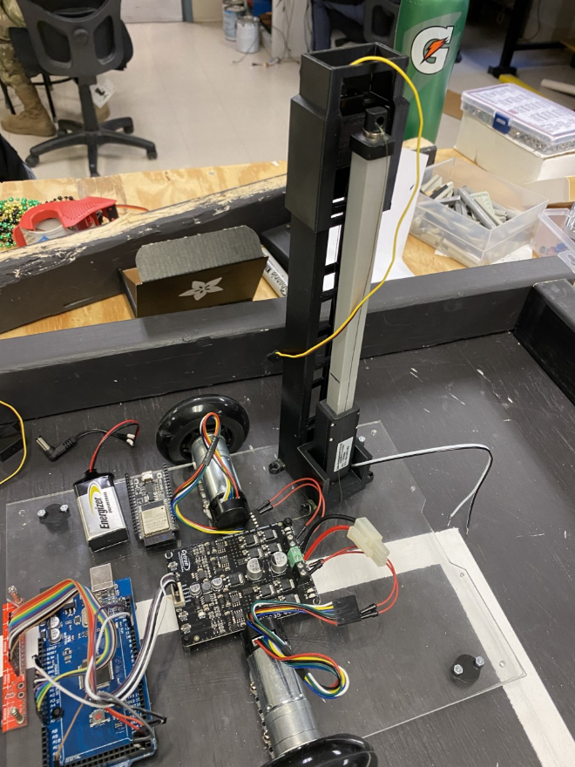

Figure 30. Chassis with Linear Actuator Arm Design

## System Summary

It was determined that the primary-secondary relationship would work best for all design and testing purposes. This involves creating all systems independently of one another and each system would simply be controlled by the secondary microcontroller, with directions from the primary microcontroller. This allows for simple testing, integration, and troubleshooting processes. The launcher has been tested and can reliably get 5 beads in the net (94.55%) and at 15 beads it has a success rate of 88.48%. The arm is fully functional and completes the desired goal of over 50% bead captures which beats the maximum cup point scoring strategy. This also will go up as the rod used for the arm will be lengthened so that more beads can be reached as only half as of now are able to be reached. The code for the arm at the moment also has some headroom for more points to be achieved as the code is not fully optimized and sometimes knocks beads off. Computer vision is needed to commence integration for all subsystems as that is the main detection for all point scoring maneuvers, however will need more work to get to a point where integration is possible. The display is fully capable of scoring points consistently and only needs a bracket to ensure it does not come undone from the robot during competition. The drivetrain subsystem is currently being completely redone as it was previously utilizing analog read from the line sensor array, however in the next iteration it will use comparators to be digitally readable by the Arduino mega.

## Progress

As each team finishes their subsystems work for different parts of the robot, progress is gained each day on the robot. This progress includes the finishing and testing of subsystems, awaiting the integration via computer vision. The first task vital to begin production of the physical robot was to create the gameboard. The next was planning of the general design of the robot to include its subsystems and so far, the current functionality of the robot, involving the movement of the robot, includes its ability to fully traverse the course by completing laps, including making the turn. The arm can obtain the beads and drop them into the cup of the launching mechanism and the launching mechanism can throw the beads, except that these functions only occur separately and need to be fully integrated into the functionality of the robot through computer visions. Other features completed on the robot include playing music while the robot is moving as well as a display that moves 4”. The figures below show images of the latest version of the robot. Figure 24 shows the line tracking device, while Figure 27 shows the current state of the robot including the integration of the wheels, motors, chassis, microcontroller, and motor driver. Casters on each of the four corners allow the bottom level of the robot to stabilize, which is seen in Figure 27 (shown below).

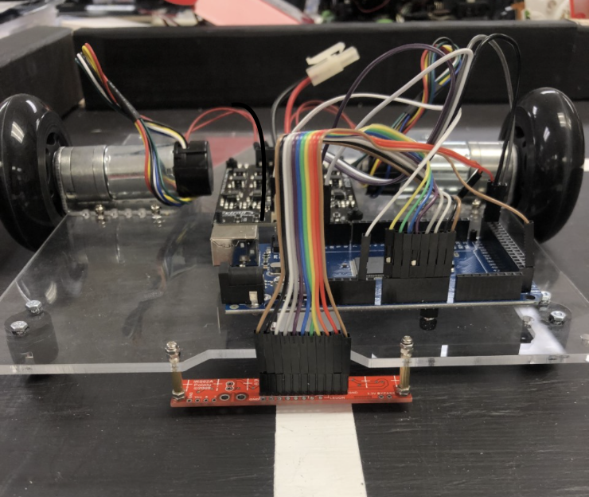

Figure 24. Front View of the first version of the Robot

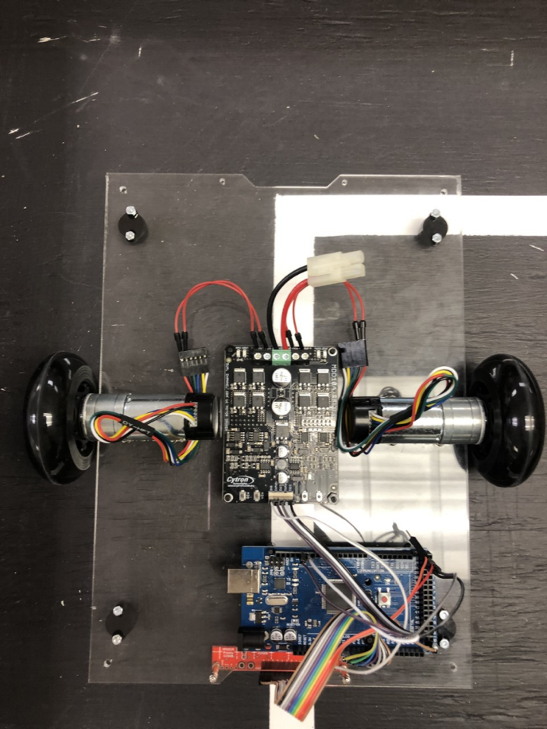

Figure 25. Top View of the first revision of the Robot

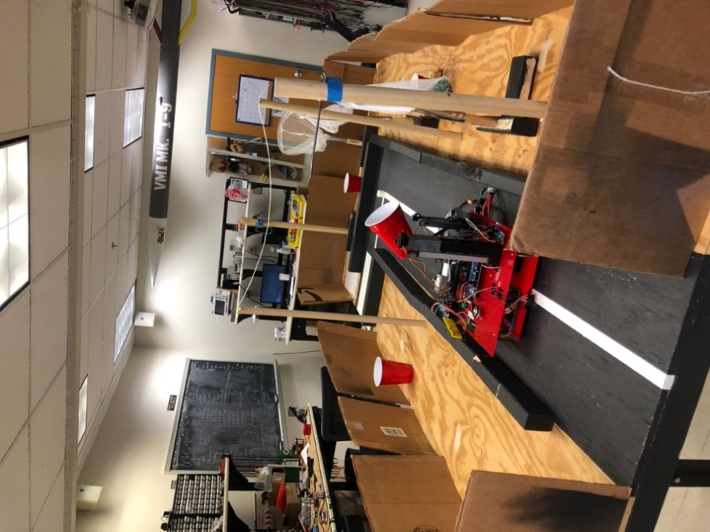

Figure 26. View of Robot on the Gameboard

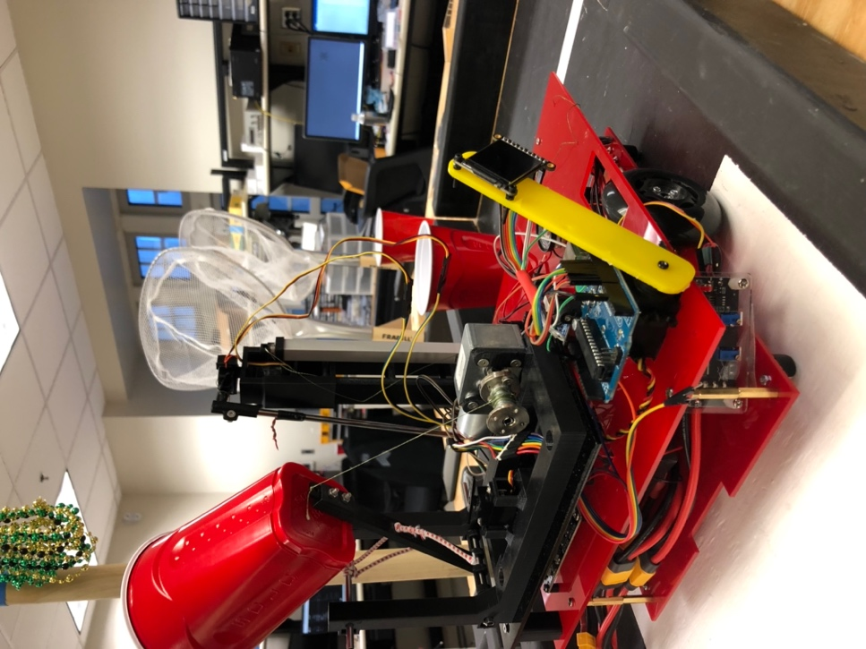

Figure 27. Current robot progress as of 12/14/2021.

# Testing

## Drivetrain Subsystem Testing

### Plan

The table is the plan for testing the Software Teams Drivetrain Test.

|  |  |  |  |  |  |  |  |  |  |  |
| --- | --- | --- | --- | --- | --- | --- | --- | --- | --- | --- |
| **Test Writer: 2022 Software Team** | | | | | | | | | | |
| **Test Case Name:** | | Robot Drivetrain - Subsystem Test | | | | | **Test ID#** | Robot-Drivetrain | | |
| **Description:** | | Checks the engineering requirement: the Drivetrain starts in the beginning square and navigates its way to the end of the track, while avoiding the edges of the track. The test was done using 11.1V LiPo batteries with 2.2Ah of capacity. | | | | | **Type: □** | □ white box | | |
| **■** black box | | |
| **Tester Information** | | | | | | | | | | |
| **Name of Tester:** | | Gordon M. | | | | | **Date:** | | 12/10/2021 | |
| **Hardware Ver:** | | Robot 1.0 | | | | | **Time:** | | 1500 | |
| **Setup:** | | Track is cleared, robot is powered and waiting in the start square, other subsystems are disabled for purposes of testing. | | | | | | | | |
| **Step** | **Action** | **Expected Result** | **Pass** | **Fail** | **N/A** | **Comments** | | | |
| 1 | Start in the beginning square press the start button | Robot fits within the 12"x12" starting square | PASS |  |  | Power consumption monitored and recorded for all steps. | | | |
| 2 | Robot approaches corner | Robot tracks the line on the track up to the corner | PASS |  |  |  | | | |
| 3 | Robot reaches the corner | Robot turns the corner and returns to the line | PASS |  |  |  | | | |
| 4 | Robot tracks line | Robot follows the line without leaving or touching the sides |  | FAIL |  | Motion is not smooth and causes erratic movement that interferes with later tests. | | | |
| 5 | Robot reaches end | Robot performs a 180 degree turn and proceeds forward |  | FAIL |  | Not reliable, sometimes misses line when aligning again. | | | |
| 6 | Robot tracks line | Robot follows the line without leaving or touching the sides |  | FAIL |  | Robot has potential of missing line and running in to barrier. | | | |
| 7 | Robot reaches the corner | Robot turns the corner and returns to the line | PASS |  |  |  | | | |
| 8 | Robot reaches the beginning | Robot halts within the starting square | PASS |  |  |  | | | |
| **Overall test result:** | | |  | FAIL |  | Improved reliability is needed | | | | |

### Results

While the drivetrain is able to perform all of these individual actions, it cannot do so reliably enough to justify a pass. The current standard is for the robot to be able to perform all 6 runs, down and back, without fault. The robot in its current state is physically capable of that but the lack of reliable line following code significantly hampers its ability to reliably perform the other tasks. The method of line following as it is does not implement a real time control system such as PID that could correct for steady state error. Instead, in its current state, it only applies a turn if the line is detected on a side. This results in a serpentine down the track that has the potential of hopping over the line or placing the robot unexpectedly before a maneuver like the corner.

## Recover Beads Subsystem Testing

### Plan

The following plan is for the Electronics Team Beads Test.

|  |  |  |  |  |  |  |  |  |  |
| --- | --- | --- | --- | --- | --- | --- | --- | --- | --- |
| **Test Writer: 2022 Electronics Team** | | | | | | | | | |
| **Test Case Name:** | | Robot Recover - Subsystem Test - beads | | | | | **Test ID#** | Robot-Recover | |
| **Description:** | | Checks the engineering requirement: The recovery mechanism starts in a neutral position then recovers beads and delivers them to the launching mechanism. The test was done using 11.1V LiPo batteries with 2.2Ah of capacity. | | | | | **Type: □** | □ white box | |
| **■** black box | |
| **Tester Information** | | | | | | | | | |
| **Name of Tester:** | | Chris Krush & Jerrod Hunziker | | | | | **Date:** | | 12/12/21 |
| **Hardware Ver:** | | Robot 1.0 | | | | | **Time:** | | 2330 |
| **Setup:** | | Power supplied. Arm is centered on trees, with beads resting on the trees. | | | | | | | |
| **Step** | **Action** | **Expected Result** | **Pass** | **Fail** | **N/A** | **Comments** | | | |
| 1 | Extend the linear actuator | extends to 21" measured from the board | PASS |  |  | Power consumption monitored and recorded for all steps. | | | |
| 2 | Rotate the arm mechanism 180 degrees | range of motion allows for movement from tree to launching mechanism | PASS |  |  | The servo allows for rotation up to 180 degrees but is not needed to place the beads into the cup. | | | |
| 3 | extend upper portion of the arm | Arm can reach out to pick the beads off the tree | PASS |  |  | The Arm Fully extends and retracts as needed | | | |
| 4 | pick beads off trees | Arm can reliably retrieve the beads from the trees | PASS |  |  | It was able to grab at least 50% beads off the tree. | | | |
| 5 | return beads to launching mechanism | beads are placed into the launching mechanism | PASS |  |  | Of the beads grabbed, it returns 90%. | | | |
| 5 | Return to neutral position | arm is returned to the starting position and profile of the robot returns to original state | PASS |  |  | Reliably returned to the starting position. | | | |
| **Overall test result:** | | | PASS |  |  | Over the performance was adequate but has room to be improved. The arm is in a usable state. | | | |

### Results

Overall, the arm is in a usable state but needs improvements for the final competition version. In its current state, the arm movement is not smooth enough, either from programming or the quality of the servo motor. The arm goes from vertical to horizontal too early and fast both by approximately 1.5 seconds. Raising the rod needs to happen 0.5 seconds later to increase the number of beads grabbed. The idea suggested to increase the number of rods to improve the probability the beads are grabbed is good but may cause a decrease in reliability in ability to place beads in the cup. Further testing is required for the addition of new rods. Higher quality servo motors will also be considered as an option to smooth out rotational movement. At the end of running both the arm and the launching subsystem the battery dropped from 12.6V to 11.4V over the course of 70 tests combined.

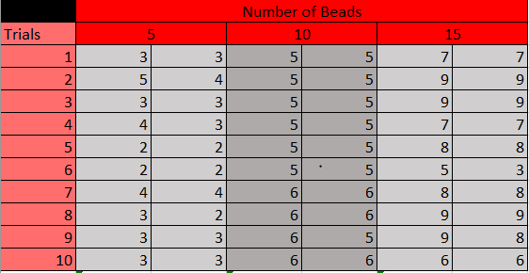

Table . Number of Beads on Tree Vs. Number Grabbed and Number Placed in Cup

The results of the arm testing are as follows:

* Percent grabbed per the number of beads on the Tree:
  + 5: 64%
  + 10: 54%
  + 15: 51.33%
* Percent from arm to cup:
  + 5: 93.63%
  + 10: 98.15%
  + 15: 96.10%

## Launcher Subsystem Testing

### Plan

The following is a plan for the Hardware Nets and Beads test.

|  |  |  |  |  |  |  |  |  |  |
| --- | --- | --- | --- | --- | --- | --- | --- | --- | --- |
| **Test Writer: 2022 Hardware Team** | | | | | | | | | |
| **Test Case Name:** | | Robot Launcher- Subsystem Test - nets and beads | | | | | **Test ID#** | Robot-Launcher | |
| **Description:** | | Checks the engineering requirement: The net starts in the neutral position, retracts and launches the beads to the nets. End goal- 50% Accuracy . The test was done using 11.1V LiPo batteries with 2.2Ah of capacity. | | | | | **Type: □** | □ white box | |
| **■** black box | |
| **Tester Information** | | | | | | | | | |
| **Name of Tester:** | | Chris Krush & Gordon Mathiesen | | | | | **Date:** | | 12/13/2021 |
| **Hardware Ver:** | | Launcher 1.0 | | | | | **Time:** | | 1500 |
| **Setup:** | | Power supplied, launching mechanism centered on the net, beads loaded into launcher | | | | | | | |
| **Step** | **Action** | **Expected Result** | **Pass** | **Fail** | **N/A** | **Comments** | | | |
| 1 | retract the launching mechanism to prep sequence | launching mechanism is prepped to receive and launch beads | PASS |  |  | Power consumption monitored and recorded for all steps. | | | |
| 2 | launch beads at the nets | a minimum of 50% accuracy with beads in the net | PASS |  |  | The launcher becomes less reliable for 4 or less beads. | | | |
| 3 | return to neutral Position | Launcher returns to the initial position | PASS |  |  |  | | | |
| **Overall test result:** | | | PASS |  |  | The launching mechanism was tested 11 times for 5, 10 and 15 beads for a total of 33 trials. The reliability was:  5 beads: 94.55%  10 beads: 98.18%  15 beads: 88.48% | | | |

### Results

The table is the number of beads to make it into from the initial amount. Another item to note is that the launcher functioned 35 times in a row without having any system level malfunction. Moving forward, to improve the reliability of the launcher, a limit switch should be added to detect when the arm of the launcher is fully back. Also, integration the encoder to allow for more precise launch angles of the beads by controlling the length of string let out by the winch. Once those items are done testing will be done again, across a larger variety of amounts of beads in the launcher.

The results from this test were also plotted, the launcher can only effectively perform with a certain number of beads per a given launch angle. To combat this, different launch angles will be used for the different rounds of competition that correlate with the number of beads available on the track and the beads the robot is likely to successfully collect using data gathered from the arm’s reliability testing. At the end of running both the arm and the launching subsystem the battery dropped from 12.6V to 11.4V over the course of 70 tests combined.

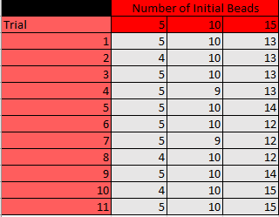

Table . Testing Results for Launcher Subsystem Testing (Initial beads Vs. beads landed in net)



Figure . Plot of Launcher Test Results

## Integrated Systems Testing

### Plan

|  |  |  |  |  |  |  |  |  |  |  |  |
| --- | --- | --- | --- | --- | --- | --- | --- | --- | --- | --- | --- |
| **Test Writer: Mardi Gras 2022 Robot** | | | | | | | | | | | |
| **Test Case Name:** | | Mardi Gras Robot Full Up System Test | | **Test ID#** | | | | Mardi Gras Robot Testing | | | |
| **Description:** | | Mardi Gras Robot - Competition Test (standard: Southeast Con 2022 Hardware Competition) | | **Type: ■** | | | | □ white box | | | |
| **■** black box | | | |
| **Tester Information** | | | | | | | | | | | |
| **Name of Tester:** | | | Mardi gras Robot Team | | | | | | | **Date:** |  |
| **Hardware Ver:** | | | Robot 1.0 | | | | | | | **Time:** |  |
| **Setup:** | | | Test run 5 times (2 qualifying, 2 semi-finals, 1 final) for 3 minutes, collect and distribute the beads, navigate the course, scored with the scoring chart in IEEE 2022 rules Sec. 8 | | | | | | | | |
| **Step** | **Action** | | **Expected Result** | | **Pass** | **Fail** | **N/A** | | **Comments** | | |
| 1 | Robot is placed in 12” X 12” X 12” box | | Robot fits in box | | PASS |  |  | | IEEE 2022 Rules Sec. 6, Line 4 | | |
| 2 | Robot placed at start position and start button pressed | | Start button labeled "start" pressed and robot begins course | | PASS |  |  | | IEEE 2022 Rules Sec. 6 line 7 | | |
| 3 | Robot Navigates Course | | Robot gathers beads | |  | FAIL |  | | Test is scored using IEEE 2022 scoring rules Sec. 8 | | |
| 4 | Robot Navigates Course | | Robot distributes beads | |  | FAIL |  | | Test is scored using IEEE 2021 scoring rules Sec. 8 | | |
| 5 | Robot Navigates Course | | Robot navigates course down and back | | PASS |  |  | | Test is scored using IEEE 2022 scoring rules Sec. 8 | | |
| 6 | Robot Navigates Course | | Robot lights up and moves display | | PASS |  |  | | Test is scored using IEEE 2022 scoring rules Sec. 8 | | |
| 7 | Robot Navigates Course | | Robot plays music | | PASS |  |  | | Test is scored using IEEE 2022 scoring rules Sec. 8 | | |
| 8 | Robot Navigates Course | | Robot Reaches the end and stops within g starting box | | PASS |  |  | | Test is scored using IEEE 2022 scoring rules Sec. 8 | | |
| 8 | Robot Navigates Course | | Robot may repeat course | |  | FAIL |  | | Test is scored using IEEE 2022 scoring rules Sec. 8 | | |
| **Overall test result:** | | | | |  | FAIL |  | | Scores for steps 3-7 totaled. | | |

### Results

The full system test was completed without the arm or launcher active. Because of this, no beads were collected or distributed. While the drivetrain was able to navigate the course, the reliability was not high enough to justify a passed test in that regard. From this test it is clear that a more advanced control system needs to be used for line following. A PID controller is planned and is being implemented before the next full system test.

## Testing Conclusions

Testing currently has not encompassed most of the robot in an integrated state. While the launcher and arm were tested while mounted on the robot, it won’t be a true test of performance without certain aspects of the integration test. For example, the arm and launcher both can perform well individually, however, the computer vision subsystem will have to align the robot for all tasks that the launcher and arm are expected to perform. Without this as part of the test, the true reliability of the robot during competition cannot be known.

Because of this, it is essential that computer vision and the associated integrated programming occurs as soon as possible. The drivetrain works independently but it needs to be integrated with the main microcontroller. Because the main microcontroller needs to control multiple aspects of the robot at once the sequencing and performance of its programming needs to be optimized significantly from its current state.

# Project plan

## Team Member’s Skills

Firstly, the members of the project did a self-assessment, determining their own strengths and weaknesses. Below are the results.

### Electronics Team:

|  |  |  |  |  |  |
| --- | --- | --- | --- | --- | --- |
| **Evaluate your relative strength in the following areas (3=high, 2=moderate, 1=neutral)** | **Jeremiah Gaulding** | **Garrett Johnson** | **John Angerer** | **Karin Teekha** | **Fawaz Rudd** |
| **Analyst (detailed problem solver)** | 3 | 2 | 3 | 2 | 2 |
| **Management (supervising to actions of others)** | 2 | 2 | 2 | 2 | 2 |
| **Motivation (self-starter)** | 3 | 2 | 3 | 3 | 3 |
| **Cooperative (works well with others)** | 2 | 3 | 3 | 3 | 3 |
| **Goal oriented (motivated by reaching goal)** | 2 | 3 | 2 | 2 | 3 |
| **Experience (technical)** | 2 | 1 | 3 | 1 | 1 |
| **Work Ethic (works hard when unsupervised)** | 3 | 2 | 3 | 2 | 3 |
| **Time management (uses time effectively)** | 3 | 2 | 3 | 2 | 3 |
| **Organization (plans complex tasks)** | 2 | 3 | 2 | 2 | 3 |
| **Scheduling/coordinating/tracking efforts** | 2 | 3 | 2 | 2 | 3 |
| **Writing about things** | 1 | 3 | 1 | 1 | 1 |
| **Building things** | 2 | 1 | 2 | 2 | 2 |
| **Testing things** | 2 | 1 | 3 | 2 | 2 |
| **Working with data and software** | 2 | 1 | 2 | 1 | 1 |
| **Doing an oral presentation** | 3 | 3 | 1 | 1 | 3 |
| **Ordering and keeping track of parts** | 2 | 3 | 3 | 2 | 2 |
| **Doing technical schematics, drawings, diagrams, charts, graphs, tables** | 2 | 2 | 3 | 3 | 2 |

### Hardware Team:

|  |  |  |  |  |
| --- | --- | --- | --- | --- |
| **Evaluate your relative strength in the following areas (3=high, 2=moderate, 1=neutral)** | **Nicholas Bryson** | **Ishmael Taylor** | **Nia Vaughan** | **Jerrod Hunziker** |
| **Analyst (detailed problem solver)** | 2 | 2 | 2 | 2 |
| **Management (supervising to actions of others)** | 2 | 2 | 2 | 2 |
| **Motivation (self-starter)** | 1 | 3 | 2 | 3 |
| **Cooperative (works well with others)** | 3 | 3 | 2 | 3 |
| **Goal oriented (motivated by reaching goal)** | 3 | 3 | 2 | 3 |
| **Experience (technical)** | 2 | 1 | 1 | 2 |
| **Work Ethic (works hard when unsupervised)** | 3 | 3 | 3 | 3 |
| **Time management (uses time effectively)** | 2 | 2 | 2 | 2 |
| **Organization (plans complex tasks)** | 2 | 2 | 2 | 2 |
| **Scheduling/coordinating/tracking efforts** | 2 | 2 | 2 | 2 |
| **Writing about things** | 3 | 1 | 3 | 1 |
| **Building things** | 2 | 3 | 2 | 2 |
| **Testing things** | 2 | 2 | 2 | 2 |
| **Working with data and software** | 1 | 2 | 1 | 1 |
| **Doing an oral presentation** | 3 | 1 | 2 | 3 |
| **Ordering and keeping track of parts** | 2 | 2 | 1 | 3 |
| **Doing technical schematics, drawings, diagrams, charts, graphs, tables** | 2 | 1 | 2 | 1 |

### Software Team:

|  |  |  |  |  |  |
| --- | --- | --- | --- | --- | --- |
| **Evaluate your relative strength in the following areas (3=high, 2=moderate, 1=neutral)** | **Charles McElroy** | **Samuel Estes** | **Trevor Weygandt** | **Gordon Mathiesen** | **Michael Jackson** |
| **Analyst (detailed problem solver)** | 3 | 2 | 3 | 3 | 2 |
| **Management (supervising to actions of others)** | 2 | 3 | 2 | 3 | 1 |
| **Motivation (self-starter)** | 2 | 2 | 3 | 3 | 3 |
| **Cooperative (works well with others)** | 3 | 3 | 3 | 2 | 3 |
| **Goal oriented (motivated by reaching goal)** | 3 | 3 | 2 | 3 | 3 |
| **Experience (technical)** | 3 | 1 | 2 | 2 | 1 |
| **Work Ethic (works hard when unsupervised)** | 3 | 2 | 3 | 3 | 2 |
| **Time management (uses time effectively)** | 2 | 3 | 2 | 2 | 3 |
| **Organization (plans complex tasks)** | 1 | 2 | 2 | 2 | 2 |
| **Scheduling/coordinating/tracking efforts** | 2 | 3 | 1 | 2 | 1 |
| **Writing about things** | 3 | 2 | 1 | 1 | 3 |
| **Building things** | 2 | 2 | 2 | 3 | 1 |
| **Testing things** | 3 | 2 | 2 | 3 | 2 |
| **Working with data and software** | 3 | 3 | 2 | 2 | 2 |
| **Doing an oral presentation** | 3 | 2 | 3 | 1 | 3 |
| **Ordering and keeping track of parts** | 1 | 2 | 2 | 2 | 3 |
| **Doing technical schematics, drawings, diagrams, charts, graphs, tables** | 3 | 1 | 2 | 3 | 2 |

### Leadership:

|  |  |  |
| --- | --- | --- |
| **Evaluate your relative strength in the following areas (3=high, 2=moderate, 1=neutral)** | **Christopher Krush** | **Alex Rice** |
| **Analyst (detailed problem solver)** | 3 | 3 |
| **Management (supervising to actions of others)** | 3 | 3 |
| **Motivation (self-starter)** | 3 | 3 |
| **Cooperative (works well with others)** | 3 | 3 |
| **Goal oriented (motivated by reaching goal)** | 3 | 2 |
| **Experience (technical)** | 2 | 2 |
| **Work Ethic (works hard when unsupervised)** | 3 | 3 |
| **Time management (uses time effectively)** | 2 | 3 |
| **Organization (plans complex tasks)** | 3 | 2 |
| **Scheduling/coordinating/tracking efforts** | 2 | 2 |
| **Writing about things** | 1 | 2 |
| **Building things** | 3 | 2 |
| **Testing things** | 3 | 1 |
| **Working with data and software** | 2 | 3 |
| **Doing an oral presentation** | 2 | 3 |
| **Ordering and keeping track of parts** | 3 | 2 |
| **Doing technical schematics, drawings, diagrams, charts, graphs, tables** | 3 | 3 |

## Project Assignments

Based on their self-assessment, the project members were then assigned to specific taskings based on their strengths and weaknesses. Filled in boxes identify selected individuals for each task.

### Electronics

|  |  |  |  |  |  |
| --- | --- | --- | --- | --- | --- |
|  | John | Garrett | Fawaz | Karin | Jeremiah |
| electronics | 2 | 3 | 2 | 2 | 2 |
| detection |  |  |  |  |  |
| navigation |  |  |  |  |  |
| integration |  |  |  |  |  |
| articulation |  |  |  |  |  |

### Software

|  |  |  |  |  |  |
| --- | --- | --- | --- | --- | --- |
|  | Gordon | Samuel | Charles | Michael | Trevor |
| software | 2 | 3 | 2 | 2 | 2 |
| detection |  |  |  |  |  |
| navigation |  |  |  |  |  |
| integration |  |  |  |  |  |
| articulation |  |  |  |  |  |

### Hardware

|  |  |  |  |  |
| --- | --- | --- | --- | --- |
|  | Ishmael | Nia | Jerrod | Nicholas |
| hardware | 3 | 3 | 2 | 2 |
| navigation |  |  |  |  |
| articulation |  |  |  |  |
| power |  |  |  |  |
| drive train & Chassis |  |  |  |  |
| integration |  |  |  |  |
| Detection System |  |  |  |  |

### Leadership

|  |  |  |
| --- | --- | --- |
|  | Alex | Chris |
| Leadership |  |  |

## Work Breakdown Structure

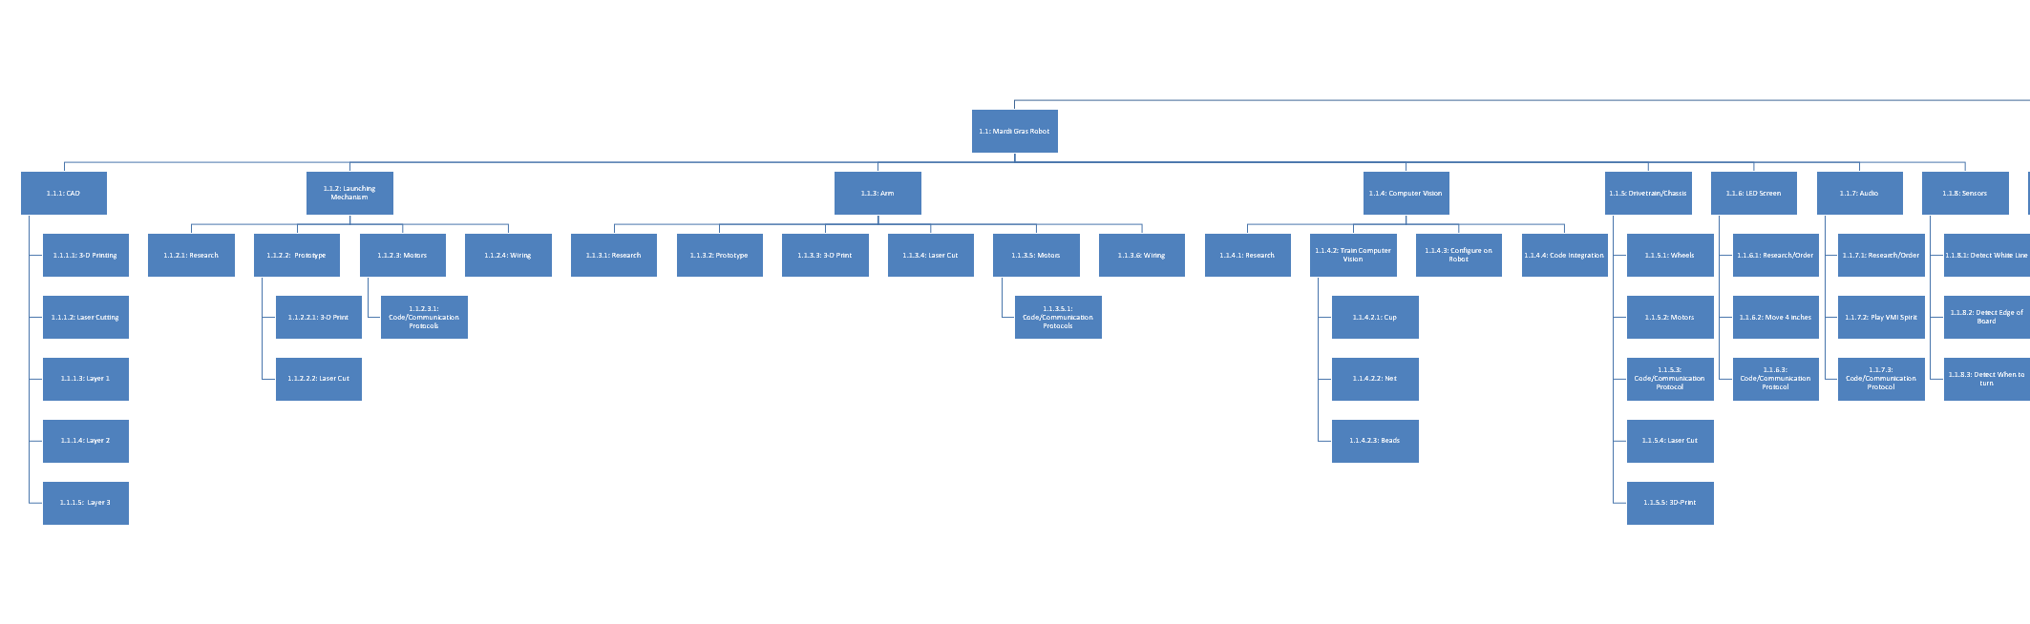

Figure 32, Work Breakdown Structure Robot Requirements

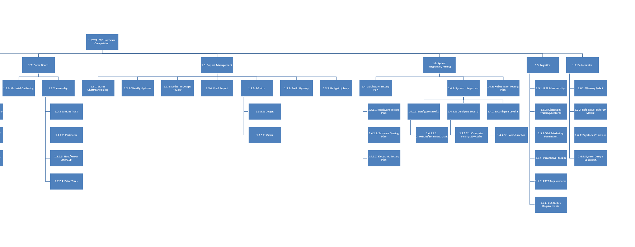

Figure 33, Work Breakdown Structure Supporting Components

## Gantt Chart

Table , Gantt Chart for Mardi Gras Robot

|  |  |  |  |  |  |  |
| --- | --- | --- | --- | --- | --- | --- |
| **Level** | **WBS** | **Task Description** | **Assigned To** | **Start** | **End** | **Notes** |
| **1** | 1 | 2022 IEEE Hardware Competition |  |  |  |  |
| **2** | 1.1 | Mardi Gras Robot | Team | 9/1/2021 | 3/25/2022 | Completion of robot before competition |
| **3** | 1.1.1 | CAD | Hardware Team | 9/10/2021 | 12/9/2021 |  |
| **4** | 1.1.1.1 | 3-D Printing | Hardware Team | 9/10/2021 | 12/1/2021 |  |
| **4** | 1.1.1.2 | Laser Cutting | Hardware Team | 9/10/2021 | 11/19/2021 |  |
| **4** | 1.1.1.3 | Layer 1 | Hardware Team | 9/10/2021 | 9/25/2021 |  |
| **4** | 1.1.1.4 | Layer 2 | Hardware Team | 9/25/2021 | 10/12/2021 |  |
| **4** | 1.1.1.5 | Layer 3 | Hardware Team | 10/12/2021 | 12/1/2021 |  |
| **3** | 1.1.2 | Launching Mechanism | Electronics/Hardware | 10/9/2021 | 11/19/2021 |  |
| **4** | 1.1.2.1 | Research | Electronics/Hardware | 10/9/2021 | 10/12/2021 |  |
| **4** | 1.1.2.2 | Prototype | Electronics/Hardware | 10/12/2021 | 10/19/2021 |  |
| **5** | 1.1.2.2.1 | 3-D Print | Hardware Team | 10/19/2021 | 10/24/2021 |  |
| **5** | 1.1.2.2.2 | Laser Cut | Hardware Team | 10/19/2021 | 10/24/2021 |  |
| **4** | 1.1.2.3 | Motors | Electronics/Hardware | 10/12/2021 | 10/15/2021 |  |
| **5** | 1.1.2.3.1 | Code/Communication Protocols | Software Team | 10/15/2021 | 11/19/2021 |  |
| **4** | 1.1.2.4 | Wiring | Electronics/Hardware | 10/31/2021 | 12/1/2021 |  |
| **3** | 1.1.3 | Arm | Electronics/Hardware | 10/10/2021 | 11/19/2021 |  |
| **4** | 1.1.3.1 | Research | Electronics Team | 10/10/2021 | 10/14/2021 |  |
| **4** | 1.1.3.2 | Prototype | Electronics Team | 10/14/2021 | 10/28/2021 |  |
| **4** | 1.1.3.3 | 3-D Print | Hardware Team | 10/14/2021 | 10/21/2021 |  |
| **4** | 1.1.3.4 | Laser Cut | Hardware Team | 10/14/2021 | 10/17/2021 |  |
| **4** | 1.1.3.5 | Motors | Electronics Team | 10/17/2021 | 10/28/2021 |  |
| **5** | 1.1.3.5.1 | Code/Communication Protocols | Software Team | 10/28/2021 | 11/15/2021 |  |
| **4** | 1.1.3.6 | Wiring | Electronics Team | 11/15/2021 | 11/19/2021 |  |
| **3** | 1.1.4 | Computer Vision | Software Team | 10/1/2021 | 12/1/2021 |  |
| **4** | 1.1.4.1 | Research | Software Team | 10/1/2021 | 10/8/2021 |  |
| **4** | 1.1.4.2 | Train Computer Vision | Software Team | 10/8/2021 | 11/19/2021 |  |
| **5** | 1.1.4.2.1 | Cup | Software Team | 10/8/2021 | 10/13/2021 |  |
| **5** | 1.1.4.2.2 | Net | Software Team | 10/13/2021 | 10/19/2021 |  |
| **5** | 1.1.4.2.3 | Beads | Software Team | 10/19/2021 | 11/1/2021 |  |
| **4** | 1.1.4.3 | Configure on Robot | Hardware Team | 11/15/2021 | 11/19/2021 |  |
| **4** | 1.1.4.4 | Code Integration | Software Team | 11/19/2021 | 12/9/2021 |  |
| **3** | 1.1.5 | Drivetrain/Chassis | Electronics Team | 10/1/2021 | 10/15/2021 |  |
| **4** | 1.1.5.1 | Wheels | Electronics Team | 10/1/2021 | 10/8/2021 |  |
| **4** | 1.1.5.2 | Motors | Electronics Team | 10/1/2021 | 10/9/2021 |  |
| **4** | 1.1.5.3 | Code/Communication Protocol | Software Team | 10/9/2021 | 11/1/2021 |  |
| **4** | 1.1.5.4 | Laser Cut | Hardware Team | 10/1/2021 | 10/15/2021 |  |
| **4** | 1.1.5.5 | 3D-Print | Hardware Team | 10/1/2021 | 10/15/2021 |  |
| **3** | 1.1.6 | LED Screen | Electronics Team | 11/10/2021 | 12/9/2021 |  |
| **4** | 1.1.6.1 | Research/Order | Electronics Team | 11/10/2021 | 11/17/2021 |  |
| **4** | 1.1.6.2 | Move 4 inches | Electronics Team | 11/17/2021 | 12/9/2021 |  |
| **4** | 1.1.6.3 | Code/Communication Protocol | Software Team | 11/17/2021 | 12/9/2021 |  |
| **3** | 1.1.7 | Audio | Electronics Team | 11/19/2021 | 12/5/2021 |  |
| **4** | 1.1.7.1 | Research/Order | Electronics Team | 11/19/2021 | 11/23/2021 |  |
| **4** | 1.1.7.2 | Play VMI Spirit | Electronics Team | 11/23/2021 | 12/5/2021 |  |
| **4** | 1.1.7.3 | Code/Communication Protocol | Software Team | 11/23/2021 | 12/5/2021 |  |
| **3** | 1.1.8 | Sensors | Electronics Team | 10/1/2021 | 10/23/2021 |  |
| **4** | 1.1.8.1 | Detect White Line | Software Team | 10/1/2021 | 10/10/2021 |  |
| **4** | 1.1.8.2 | Detect Edge of Board | Software Team | 10/10/2021 | 10/14/2021 |  |
| **4** | 1.1.8.3 | Detect When to turn | Software Team | 10/14/2021 | 10/23/2021 |  |
| **2** | 1.2 | Game Board | Hardware Team | 9/1/2021 | 9/15/2021 |  |
| **3** | 1.2.1 | Material Gathering | Hardware Team | 9/1/2021 | 9/15/2021 |  |
| **3** | 1.2.2 | Assembly | Hardware Team | 9/1/2021 | 9/15/2021 |  |
| **4** | 1.2.2.1 | Main Track | Hardware Team | 9/1/2021 | 9/15/2021 |  |
| **4** | 1.2.2.2 | Perimeter | Hardware Team | 9/1/2021 | 9/15/2021 |  |
| **4** | 1.2.2.3 | Nets/Power Line/Cup | Hardware Team | 9/1/2021 | 9/15/2021 |  |
| **4** | 1.2.2.4 | Paint Track | Hardware Team | 9/1/2021 | 9/15/2021 |  |
| **2** | 1.3 | Project Management | PM/APM | 9/1/2021 | 3/25/2022 |  |
| **3** | 1.3.1 | Gantt Chart/Scheduling | PM/APM | 9/1/2021 | 12/9/2021 |  |
| **3** | 1.3.2 | Weekly Updates | Team Leads | 9/1/2021 | 3/25/2022 |  |
| **3** | 1.3.3 | Midterm Design Review | Team | 10/19/2021 | 11/19/2021 |  |
| **3** | 1.3.4 | Final Report | Team | 11/19/2021 | 12/9/2021 |  |
| **3** | 1.3.5 | T-Shirts | Cadet Gaulding | 9/1/2021 | 12/9/2021 |  |
| **4** | 1.3.5.1 | Design | Cadet Gaulding | 9/1/2021 | 12/1/2021 |  |
| **4** | 1.3.5.2 | Order | Cadet Gaulding | 12/1/2021 | 12/9/2021 |  |
| **3** | 1.3.6 | Trello Upkeep | PM | 9/1/2021 | 3/25/2022 |  |
| **3** | 1.3.7 | Budget Upkeep | APM | 9/1/2021 | 3/25/2022 |  |
| **2** | 1.4 | System Integration/Testing | Team | 12/1/2021 | 3/15/2022 |  |
| **3** | 1.4.1 | Subteam Testing Plan | PM/APM | 12/1/2021 | 3/15/2022 |  |
| **4** | 1.4.1.1 | Hardware Testing Plan | Hardware | 12/1/2021 | 3/15/2022 |  |
| **4** | 1.4.1.2 | Software Testing Plan | Software | 12/1/2021 | 3/15/2022 |  |
| **4** | 1.4.1.3 | Electronic Testing Plan | Electronics | 12/1/2021 | 3/15/2022 |  |
| **3** | 1.4.2 | System Integration | PM/APM | 10/1/2021 | 3/15/2022 |  |
| **4** | 1.4.2.1 | Configure Level 1 | PM/APM | 10/1/2021 | 10/20/2021 |  |
| **5** | 1.4.2.1.1 | Drivetrain/Sensors/Chassis | Electronics | 10/1/2021 | 10/20/2021 |  |
| **4** | 1.4.2.2 | Configure Level 2 | PM/APM | 10/17/2021 | 11/19/2021 |  |
| **5** | 1.4.2.2.1 | Computer Vision/LED/Audio | Software | 10/17/2021 | 11/19/2021 |  |
| **4** | 1.4.2.3 | Configure Level 3 | PM/APM | 11/15/2021 | 12/9/2021 |  |
| **5** | 1.4.2.3.1 | Arm/Launcher | Electronics/Hardware | 11/15/2021 | 12/9/2021 |  |
| **3** | 1.4.3 | Robot Team Testing Plan | Team | 11/3/2021 | 11/8/2021 |  |
| **2** | 1.5 | Logistics | PM/APM | 9/1/2021 | 3/31/2022 |  |
| **3** | 1.5.1 | IEEE Memberships | PM | 9/1/2021 | 10/1/2022 |  |
| **3** | 1.5.2 | Classroom Training/Lectures | PM | 9/1/2021 | 10/1/2022 |  |
| **3** | 1.5.3 | VMI Marketing Permission | PM/APM | 10/1/2021 | 10/8/2021 |  |
| **3** | 1.5.4 | Vans/Travel Means | PM/APM | 10/1/2021 | 12/5/2021 |  |
| **3** | 1.5.5 | ABET Requirements | PM/APM | 9/1/2021 | 3/31/2022 |  |
| **3** | 1.5.6 | EE421/471 Requirements | PM/APM | 9/1/2021 | 5/16/2022 |  |
| **2** | 1.6 | Deliverables | Team | 9/1/2021 | 3/31/2022 |  |
| **3** | 1.6.1 | Winning Robot | Team | 9/1/2021 | 3/31/2022 |  |
| **3** | 1.6.2 | Safe Travel To/From Mobile | PM/APM | 3/27/2022 | 3/31/2022 |  |
| **3** | 1.6.3 | Capstone Complete | Team | 9/1/2021 | 3/25/2022 |  |
| **3** | 1.6.4 | System Design Education | Team | 9/1/2021 | 10/1/2021 |  |

## Work Package

Attached below is the work package for the high-level components of the Mardi Gras Robot Construction.

Table . Work Package for high level systems

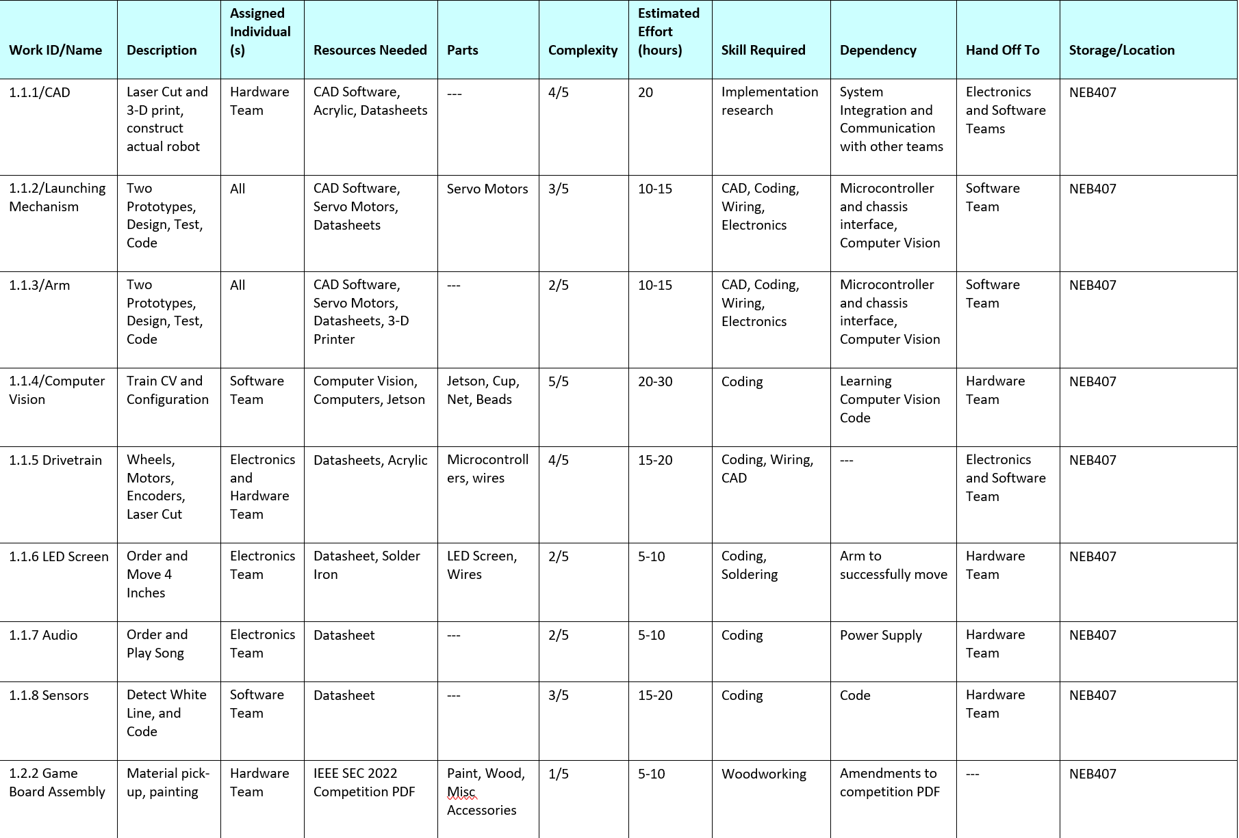

## Budget Allocation

The Capstone team of the class of 2022 was given a budget of 4022.22 USD for funding on the competition robot. The current state of the budget can be seen in figure 18 showing the amounts spent by each team and the remaining budget. This was broken up between the three teams and the PM/APM. The breakdown between teams can be seen below in figure 19 along with the amount currently spent by each team and remaining funds. $1500 has been allotted to both the hardware and electronics team and $500 allotted to the software and PM/APM team individually. Due to the order process following state guidelines, the ordering process has a mark-up added to all purchases and falls into the shipping and mark-up portion of the chart.

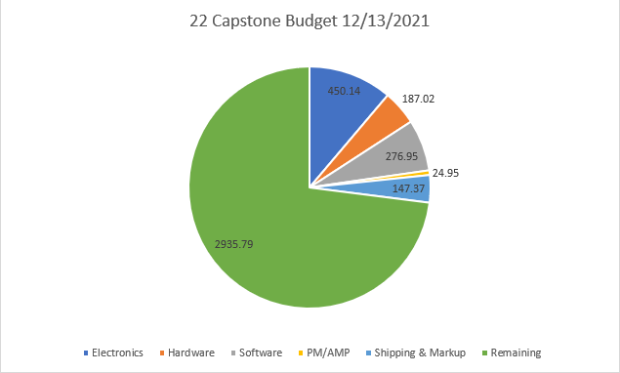

Figure 18. Funds as of 13DEC2021

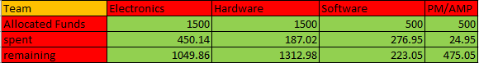

Table 19. Fund Allocation

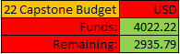

Table 20. Overall Funds

The items purchased by each team are listed below in figures 21 - 24. These lists also include some future purchases that will be made before the completion of the robot but have not been counted against the remaining budget. An estimated $500 will be spent on the remaining research and development of systems within the robot. Another $1000 will be spent on upgrades for the final iteration of the robot to be used in the competition. The remaining funds will be spent on replacement parts and act as flex for unanticipated purchases.

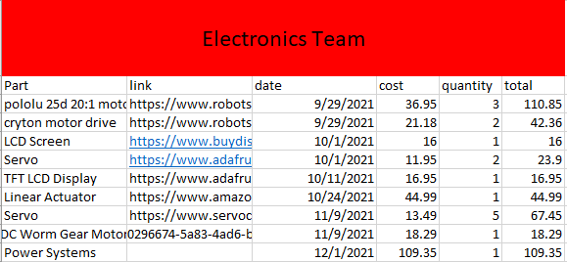

Table 21. Electronics Team Purchases

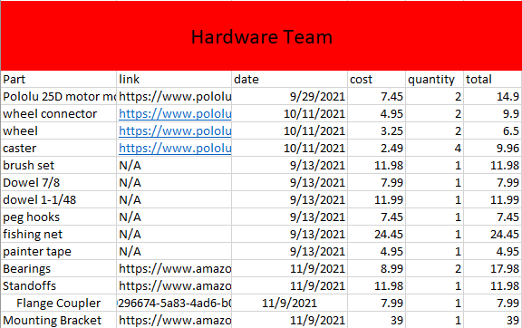

Table 22. Hardware Team Purchases

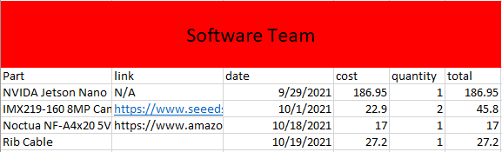

Table 23. Software Team Purchases

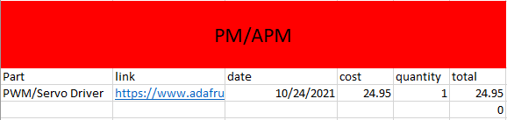

Table 24. PM/APM Team Purchases

# Sources

(Reference your text and all your sources from your Research Survey. Since you likely have many from the Internet, a reference on how to do that is below.)

Footnotes for Internet sources follow this basic pattern, omitting any items that are not available[13]:

1. Author of the actual item cited (often not given)
2. Title or heading of the item (in quotation marks)
3. Name of the website (underlined)
4. Name of the site's editor or complier (if any), with "ed."
5. Date of electronic publication or latest update of the site
6. Name of the organization responsible for the site
7. Date that you downloaded the information
8. Full Internet address (in angle brackets)

* There are no page numbers to cite in footnotes for Internet material. (Do not refer to the page numbers of your printout sheets.)
* When you have to divide an Internet address onto two lines, split it after a slash or before a period.
* If your computer turns the Internet address into a blue hyperlink, cancel this. (Click on the address with the left mouse button: go to Hyperlink; click on Remove Hyperlink)

# Appendicies

## ABET Requirements

Below are the seven requirements set by ABET to ensure that each student has developed proficiency in each one. The responses to each of these ABET requirements will be written by each student of the capstone team and will represent their response as to how these abilities were obtained over the course of their engineering studies at VMI.

1. An ability to identify, formulate, and solve complex engineering problems by applying principles of engineering, science, and mathematics.
2. An ability to apply engineering design to produce solutions that meet specified needs with consideration of public health, safety, and welfare, as well as global, cultural, social, environmental, and economic factors.
3. An ability to communicate effectively with a range of audiences.
4. An ability to recognize ethical and professional responsibilities in engineering situations and make informed judgement, which must consider the impact of engineering solutions in global, economic, environmental, and social contexts.
5. An ability to function effectively on a team whose members together provide leadership, create a collaborative and inclusive environment, establish goals, plan tasks, and meet objectives.
6. An ability to develop and conduct appropriate experimentation, analyze, and interpret data, and use engineering judgment to draw conclusions.
7. An ability to acquire and apply new knowledge as needed, using appropriate learning strategies.

## C&C Responses

Essay identifies distinctive cultural factors influencing design (may be something that it has in common with another culture, or it may be something that makes it different than others)

States what activities and assignments from your engineering curriculum have facilitated your learning about the cultural factors

For A level performance must be at least 750 words in length

## Acronyms

1. Touma, Daniela. IEEE Southeast Con 2022 Hardware Competition Rules.
2. Touma, Daniela. IEEE Southeast Con 2022 Hardware Competition Rules.
3. Touma, Daniela. IEEE Southeast Con 2022 Hardware Competition Rules.
4. Touma, Daniela. IEEE Southeast Con 2022 Hardware Competition Rules.
5. Touma, Daniela. IEEE Southeast Con 2022 Hardware Competition Rules.
6. Touma, Daniela. IEEE Southeast Con 2022 Hardware Competition Rules.
7. Touma, Daniela. IEEE Southeast Con 2022 Hardware Competition Rules.
8. Touma, Daniela. IEEE Southeast Con 2022 Hardware Competition Rules.
9. 9 Touma, Daniela. IEEE Southeast Con 2022 Hardware Competition Rules.
10. Touma, Daniela. IEEE Southeast Con 2022 Hardware Competition Rules.
11. https://github.com/dusty-nv/jetson-inference
12. https://github.com/dusty-nv/jetson-inference
13. “MLA Footnoting – Electronic Sources”, The Dawson College Style Sheet, 7 Feb 2004, Dawson College, 12 May 2009, [http://dept.dawsoncollege.qc.ca/stylesheet/mla-foot.htm]